Set of 10 Questions
Q. 1: You can manage the test actions and the test or function library steps using the _________ menu commands
-->
0in 0in 0pt" class=MsoNormal>
A. File
B. Edit
C. Automation
D. Tools

<<<<<< =================== >>>>>>

Q. 2: To expand all the steps in the keyword view which option you would use from the View menu.

A. Expand
B. Expand All
C. Expand Items
D. Expand Rows

<<<<<< =================== >>>>>>

Q. 3: What is the shortcut key to open a Step Generator?

A. F2
B. F5
C. F6
D. F7

<<<<<< =================== >>>>>>

Q. 4: Function Definition Generator in found in which menu option.

A. File
B. Tools
C. Insert
D. View

<<<<<< =================== >>>>>>

Q. 5: The shortcut keys for Record, Stop and Run respectively are

A. F3, F4, F5
B. F4, F3, F5
C. F4, F5, F3
D. F3, F5, F4

<<<<<< =================== >>>>>>

Q. 6: What is the shortcut key for opening an Object Repository?

A. Alt+R
B. Shift+R
C. Ctrl+R
D. Shift+O+R

<<<<<< =================== >>>>>>

Q. 7: Shortcut key to Insert/Remove a breakpoint is

A. F9
B. F8
C. Ctrl+b
D. Shift+b

<<<<<< =================== >>>>>>

Q. 8: The __________ runs only the current line of the script. If the current line calls a method, the method is displayed in the view but is not performed.

A. Step over
B. Step out
C. Step into
D. Step Till

<<<<<< =================== >>>>>>

Q. 9: The ________ runs only the current line of the script. When the current line calls a method, the method is performed in its entirety, but is not displayed in the view.

A. Step Over
B. Step Out
C. Step Into
D. Step Till

<<<<<< =================== >>>>>>

Q. 10: What is the shortcut key to clear all Breakpoints?

A. Ctrl+Shift+F9
B. Shift+Ctrl+F9
C. Alt+Shift+F9
D. Alt+Ctrl+F9
Question No. | Correct Answer
Q. 1 | B
Q. 2 | B
Q. 3 | D
Q. 4 | C
Q. 5 | A
Q. 6 | C
Q. 7 | A
Q. 8 | C
Q. 9 | A
Q. 10 | A

Q. 11: Using the Object Spy, you can view

A. The run-time or test object properties and methods of any object in an open application.
B. The run-time or test object properties of any object in an open application.
C. The test object properties and methods of any object in an open application.
D. The run-time object properties and methods of any object in an open application.

<<<<<< =================== >>>>>>

Q. 12: There are ________ object type filters in Object spy dialog box.

A. Two
B. Three
C. Four
D. Five

<<<<<< =================== >>>>>>

Q. 13: In the Object Spy window, in the Properties Tab

A. Copying of Properties and its values is possible with CTRL+C
B. Copying of Properties and its values is possible by right clicking on it and choosing copy.
C. Copying of Properties and its values is possible with both A. and B. methods
D. Copying of Properties and its values is possible is not possible

<<<<<< =================== >>>>>>

Q. 14: In the Object Spy window, in the methods Tab

A. Copying of Methods is possible with CTRL+C
B. Copying of Methods is possible by right clicking on it and choosing copy.
C. Copying of Methods is possible with both A. and B. methods
D. Copying of Methods is possible is not possible

<<<<<< =================== >>>>>>

Q. 15: Object Spy dialog box

A. Can be resized
B. Cannot be resized

<<<<<< =================== >>>>>>

Q. 16: The ___________ are the highest level of the test hierarchy in the Keyword view.
A. Tests
B. Steps
C. Call to Actions
D. Actions

<<<<<< =================== >>>>>>

Q. 17: You can copy and paste or drag and drop actions to move them to a different location within a test

A. True
B. False

<<<<<< =================== >>>>>>

Q. 18: You can print the contents of the Keyword View to your Windows default printer (and even preview the contents prior to printing.

A. True
B. False

<<<<<< =================== >>>>>>

Q. 19: In the Keyword View, you can also view properties for items such as checkpoints.

A. True
B. False

<<<<<< =================== >>>>>>

Q. 20: In the step Browser > Page > Edit > Set "Genius", identify container object(s)

A. Browser
B. Edit
C. Page
D. Both Browser & Page

Question No. | Correct Answer
Q. 11 | A
Q. 12 | A
Q. 13 | A
Q. 14 | A
Q. 15 | A
Q. 16 | D
Q. 17 | A
Q. 18 | A
Q. 19 | A
Q. 20 | D

Q. 21: Object Spy can be found in __________ menu.

A. Tool
B. Tools
C. Task
D. Tasks

<<<<<< =================== >>>>>>

Q. 22: The ________________ displays the open documents side-by-side.

A. Tile Vertically
B. Tile Horizontally
C. Cascade
D. Tile Cascade

<<<<<< =================== >>>>>>
Q. 23: For opening the Quick Test Professional Help we can use _________

A. F3
B. F5
C. F1
D. F2

<<<<<< =================== >>>>>>

Q. 24: If QTP cannot find any object that matches the description, or if it finds more than one object that matches, QuickTest may use the ___________________ mechanism to identify the object.

A. Ordinal Identifier
B. Index Identifier
C. Smart Identification
D. Assistive Identification

<<<<<< =================== >>>>>>

Q. 25: You can configure the _________ and ___________.properties that QuickTest uses to record descriptions of the objects in your application

A. Mandatory, assistive, and ordinal identifier
B. Mandatory, required, and ordinal identifier
C. Smart, assistive, and ordinal identifier
D. Index, assistive, and ordinal identifier

<<<<<< =================== >>>>>>

Q. 26: The ___________ property set for each test object is created and maintained by QuickTest.

A. Run-Time Object
B. Test Object
C. Smart Identification Object
D. Assistive Object

<<<<<< =================== >>>>>>

Q. 27: You can access and perform ______________ methods using the Object property.

A. Run-Time Object
B. Test Object
C. Smart Identification Object
D. Assistive Object

<<<<<< =================== >>>>>>

Q. 28: You can view or modify the test object property values that are stored with your test in the _______________

A. Information Pane
B. Data Table
C. Information Pane & Data Table Both
D. Object Properties & Object Repository dialog box.

<<<<<< =================== >>>>>>

Q. 29: You can retrieve or modify property values of the test object during the run session by adding _______________ statements in the Keyword View or Expert View.

A. GetROProperty & SetROProperty
B. GetTOProperty & SetTOProperty
C. GetTOProperty & SetROProperty
D. GetROProperty & SetTOProperty

<<<<<< =================== >>>>>>

Q. 30: If the available test object methods or properties for an object do not provide the functionality you need, you can access ______________ of any run-time object using the Object property.

A. The internal methods and properties
B. The mandatory methods and properties
C. The selective methods and properties
D. The assistive methods and properties
Question No. | Correct Answer
Q. 21 | B
Q. 22 | A
Q. 23 | C
Q. 24 | C
Q. 25 | A
Q. 26 | B
Q. 27 | A
Q. 28 | D
Q. 29 | B
Q. 30 | A

Q. 31: The Information pane provides a list of _________ in the test:
A. Semantic errors
B. Syntax errors
C. Common errors
D. Logic errors
<<<<<< =================== >>>>>>

Q. 32: When we switch from Expert view to the Keyword view, QTP automatically checks for syntax errors in the test and shows them in the information pane.
A. True
B. False
<<<<<< =================== >>>>>>
Q.33: If the information pane is not open, QTP automatically opens it in case a syntax error is detected.
A. True
B. False
<<<<<< =================== >>>>>>

Q. 34: The __________ provides a list of the resources that are specified in your test but cannot be found.
A. Missing pane
B. Missing Resources pane
C. Resources pane
D. Missing Items pane
<<<<<< =================== >>>>>>

Q. 35: Whenever you open a test or a function library, QTP automatically checks for the availability of specified resources.
A. True
B. False
<<<<<< =================== >>>>>>

Q. 36: The Data Table does not assist you in parameterize your test.
A. True
B. False

<<<<<< =================== >>>>>>

Q. 37: Tabs in the Debug Viewer pane are:
A. Watch, Variables, Debug
B. Watch, Data, Command
C. Watch, Variables, Command
D. View, Variables, Command
<<<<<< =================== >>>>>>

Q. 38: The ________ tab enables you to view the current value of any variable or VBScript expression.
A. Watch
B. View
C. Locate
D. Current
<<<<<< =================== >>>>>>

Q. 39: The _________ tab displays the current value of all variables that have been recognized up to the last step performed in the run session.
A. View
B. Variables
C. Locate
D. Current
<<<<<< =================== >>>>>>

Q. 40: The___________ tab enables you to run a line of script to set or modify the current value of a variable or VBScript object in your test or function library.
A. View
B. Variables
C. Command
D. Current

Question No. | Correct Answer
Q. 31 | B
Q. 32 | A
Q. 33 | A
Q. 34 | B
Q. 35 | A
Q. 36 | B
Q. 37 | C
Q. 38 | A
Q. 39 | B
Q. 40 | C

Q. 41: QuickTest processes comments when it runs a test.

A. True
B. False

<<<<<< =================== >>>>>>

Q. 42: Press __________ to add a new step below the currently selected step.

A. F8
B. Shift + A
C. F0
D. Shift + A + Q

<<<<<< =================== >>>>>>

Q. 43: While working with the Keyword View, you can _________ steps to move them to a different location in a test or in an action

A. Copy and Paste
B. Cut and Paste
C. Drag and drop
D. Both A. and C.

<<<<<< =================== >>>>>>

Q. 44: You can specify the order in which the columns are displayed in the Keyword view.

A. True
B. False

<<<<<< =================== >>>>>>

Q. 45: You can view _________ while working with keyword view.

A. Object properties
B. Action properties
C. Action call properties
D. Checkpoint properties
E. Output value properties
F. None of the above
G. All of above

<<<<<< =================== >>>>>>

Q. 46: You cannot manage some aspects of a local object repository using the QuickTest Object Repository automation object model.

A. True
B. False

<<<<<< =================== >>>>>>

Q. 47: For each action, you can use a combination of objects from your local and shared object repositories.

A. True
B. False

<<<<<< =================== >>>>>>

Q. 48: QuickTest adds all new objects to the local object repository even if one or more shared object repositories are already associated with the action assuming that an object with the same description does not already exist in one of the associated shared object repositories.

A. True
B. False

<<<<<< =================== >>>>>>

Q. 49: If a child object is added to a local object repository, and its parents are in a shared object repository, then you have to manually drag and drop its parent objects from shared object repository to local object repository.

A. True
B. False

<<<<<< =================== >>>>>>

Q. 50: The ________ is not accessible as a separate file

A. Local object repository
B. Shared object repository
C. Both
D. None
Question No. | Correct Answer
Q. 41 | B
Q. 42 | A
Q. 43 | D
Q. 44 | A
Q. 45 | G
Q. 46 | B
Q. 47 | A
Q. 48 | A
Q. 49 | B
Q. 50 | A

Q. 51: You can use the Keyword View to add a step ___________ in your test.

A. At the end
B. Below the currently selected step
C. At the beginning
D. At any point

<<<<<< =================== >>>>>>

Q. 52: The Documentation cell is ___________.

A. Read-only
B. Write-only
C. Read and Write
D. Read write & execute

<<<<<< =================== >>>>>>

Q. 53: An Item column can be any of the following:

A. A test object
B. A statement like Dim
C. A step generated by step generator
D. All of above

<<<<<< =================== >>>>>>

Q. 54: The Operation cell in the keyword view specifies the operation to be performed on the item listed in the ___________ Column.

A. Operation
B. Documentation
C. Item
D. Value

<<<<<< =================== >>>>>>

Q. 55: Even if the Item column in the Keyword View is displayed to the right of the Operation column, you must still first select an item to view the list of available operations in the Operation column.

A. True
B. False

<<<<<< =================== >>>>>>

Q. 56: The Value cell in the keyword view can contain ___________ Value

A. Constant
B. Parameter
C. Both A. & B.
D. None of these

<<<<<< =================== >>>>>>

Q. 57: The ______________ enables you to encode your passwords and place secure values into the Data Table.

A. Password Encoder
B. Password Decoder
C. Password Encode
D. Password Decode

<<<<<< =================== >>>>>>

Q. 58: You can also encrypt strings in Data Table cells using the _____________ option in the Data Table menu.

A. Decrypt
B. Encrypt
C. Encrypt Code
D. Decrypt Code

<<<<<< =================== >>>>>>

Q. 59: In addition to adding standard statement steps to your test using the Keyword View, you can also insert
A. Checkpoint step
B. Output value step
C. Comment step
D. All of above

<<<<<< =================== >>>>>>

Q. 60: The correct syntax of the conditional statement starting with Do is ________

A. Do While
B. Do Until
C. Do Next
D. Both A. and B.
Question No. | Correct Answer
Q. 51 | D
Q. 52 | A
Q. 53 | D
Q. 54 | C
Q. 55 | A
Q. 56 | C
Q. 57 | A
Q. 58 | B
Q. 59 | D
Q. 60 | D

Q. 61: In the Object Repository window.

A. Local objects are editable (black)
B. Shared objects are in read-only format (gray)
C. Local objects are in read-only format (gray)
D. Shared objects are editable (black)

<<<<<< =================== >>>>>>

Q. 62: Mark the true statement

A. You can delete objects from a shared object repository using the Object Repository window.
B. You can delete objects from the local object repository using the Object Repository Manager
C. You can delete objects from the local object repository using the Object Repository window
D. You can delete objects from a shared object repository using the Object Repository Manager

<<<<<< =================== >>>>>>

Q. 63: You can modify an object stored in a shared object repository.

A. Using the Object Repository Manager
B. Using the Object Repository window
C. You can copy it to the local object repository and then modify its properties
D. You cannot modify properties of objects stored in Shared object repository

<<<<<< =================== >>>>>>
Q. 64: If an object is contained in both local and shared repositories then, during a run session.

A. QuickTest will use the object in the local object repository
B. QuickTest will use the object in the Shared object repository
C. There will be a conflict
D. QuickTest will use Descriptive Programming

<<<<<< =================== >>>>>>

Q. 65: When you copy an object to the local object repository

A. Its parent objects are also copied to the local object repository
B. Its parent objects are not copied to the local object repository
C. You have to manually copy its parent objects are also copied to the local object repository
D. You have to manually drag and drop its parent objects

<<<<<< =================== >>>>>>

Q. 66: For tests, you can also view test object properties and property values for objects in the Active Screen, regardless of whether the objects are stored in the object repository.

A. True
B. False

<<<<<< =================== >>>>>>

Q. 67: Object Properties window differs for objects stored in Shared and Local object repository.

A. True
B. False

<<<<<< =================== >>>>>>

Q. 68: You can rename objects in the shared object repository using the Object Repository Manager

A. True
B. False, you cannot rename objects in shared object repository

<<<<<< =================== >>>>>>

Q. 69: When you modify the name of an object in the local object repository, the name is automatically updated in ___________ for all occurrences of the object.

A. in the Keyword View
B. in the Expert View
C. Both Keyword and Expert View
D. Changing name of an object doest not effect keyword or expert view

<<<<<< =================== >>>>>>

Q. 70: When you modify the name of an object in a shared repository, the name is automatically updated in all tests open on the same computer that use the object repository as soon as you make the change, even if you have not yet saved the object repository with your changes.

A. True
B. False
Question No. | Correct Answer
Q. 61 | A, B
Q. 62 | C, D
Q. 63 | A, C
Q. 64 | A
Q. 65 | A
Q. 66 | A
Q. 67 | A
Q. 68 | A
Q. 69 | C
Q. 70 | A

Q. 71: -->
'Arial','sans-serif'; COLOR: #002060">'Browser navigation timeout' is in which tab of Test Settings (File->Settings) window.
A. Properties
B. Resources
C. Web
D. Web Settings
<<<<<< =================== >>>>>>
Q. 72: How many tabs are there in Test Settings (File->Settings) window?
A. 7
B. 6
C. 5
D. 8
<<<<<< =================== >>>>>>
Q. 73: Identify the tabs in the Test Settings (File->Settings) window
A. Properties, Run, Resources, Parameters, Environment, Web, Recovery
B. Properties, Run, Resources, Parameters, Environment, Web Settings, Recovery
C. Properties, Run Options, Resources, Parameters, Environment, Web, Recovery
D. Properties, Run, Resources, Input Parameters, Environment, Web, Recovery

<<<<<< =================== >>>>>>

Q. 74: 'Generate Script' is in which tab of Test Settings (File->Settings) window
A. Properties
B. Web
C. Resources
D. Recovery

<<<<<< =================== >>>>>>
Q. 75: The following are the four main columns in the Keyword view
A. Item, Operation, Value, Comments
B. Item, Operation, Value, Documentation
C. Item, Operation, Property, Documentation
D. Number, Operation, Value, Documentation
<<<<<< =================== >>>>>>

Q. 76: For each object and method in an Expert View statement, a corresponding row exists in the Keyword View.
A. True
B. False
C. There is a problem with the statement.
D. None of above

<<<<<< =================== >>>>>>

Q. 77: You can work on one or several function libraries at the same time.
A. True
B. False
<<<<<< =================== >>>>>>

Q. 78: You can insert additional steps on the test objects captured in the Active screen after the recording session.
A. True
B. False
<<<<<< =================== >>>>>>

Q. 79: The Active Screen enables you to parameterize object values and insert checkpoints
A. True
B. False
<<<<<< =================== >>>>>>

Q. 80: A QTP user can increase or decrease the active screen information saved with the test.
A. True
B. False

 | Question No. | Correct Answer
 | Q. 71 | C
 | Q. 72 | A
 | Q. 73 | A
 | Q. 74 | A
 | Q. 75 | B
 | Q. 76 | A
 | Q. 77 | A
 | Q. 78 | A
 | Q. 79 | A
 | Q. 80 | A

Q. 81: An __________ assigns a numerical value to a test object that indicates its order or location relative to other objects with an otherwise identical description

A. Index identifier.
B. Ordinal identifier.
C. SMART ID identifier.
D. Original identifier.

<<<<<< =================== >>>>>>

Q. 82: You can add an object to the local object repository only if that object does not already exist in a shared object repository that is associated with the action. If an object already exists in an associated shared object repository, you can add it to the local object repository using the ______________ option.

A. Copy from Shared Repository
B. Copy from Shared Object Repository
C. Copy to Local
D. Copy to Local repository

<<<<<< =================== >>>>>>
Q. 83: You can copy, paste, and move objects in the local object repository using the Object Repository window, and copy, paste, and move objects both within a shared object repository and between shared object repositories using the Object Repository Manager. But you cannot copy objects from a shared object repository to the local object repository to modify them locally

A. True
B. False

<<<<<< =================== >>>>>>

Q. 84: At the time of copying, pasting and moving objects, you cannot move an object to any of its descendants.

A. True
B. False

<<<<<< =================== >>>>>>

Q. 85: When you remove a step from your test, its corresponding object is also removed from the object repository

A. True
B. False

<<<<<< =================== >>>>>>

Q. 86: You can use the Find and Replace dialog box to replace property or object names.
A. True
B. False
<<<<<< =================== >>>>>>

Q. 87: The Object Repository window is __________ during record and run sessions

A. Read-only
B. Rad-write only
C. Read-write and enable
D. None of above

<<<<<< =================== >>>>>>

Q. 88: In the Associated Repositories tab of the Action Properties dialog box, the __________ object repository is always listed first and cannot be moved down the priority list or deleted.

A. Local
B. Shared
C. Both
D. None

<<<<<< =================== >>>>>>

Q. 89: In the Associated Repositories tab of the Action Properties dialog box, although we can order the object repositories according to our choice except the fact that Shared Repository remains the first one and cannot be removed.

A. True
B. False

<<<<<< =================== >>>>>>

Q. 90: If your object repositories are stored in the file system and you want other users or Mercury products to be able to run this action on other computers, you should set the file path as a ______________.

A. Absolute path
B. Relative path
C. Both
D. None of above
Question No. | Correct Answer
Q. 81 | B
Q. 82 | C
Q. 83 | B
Q. 84 | A
Q. 85 | B
Q. 86 | B
Q. 87 | A
Q. 88 | A
Q. 89 | B
Q. 90 | B

Q. 91: Panes in QTP can have one of the following statesâ€”docked or floating.
A. True
B. False
<<<<<< =================== >>>>>>

Q. 92: Which of the following statement is True:
A. Quick Test enables you to open and work on one test at a time
B. Quick Test enables you to open and work on two tests at a time
C. Quick Test enables you to open and work on predefined number of tests at a time
D. Quick Test enables you to open and work on nine test at a time
<<<<<< =================== >>>>>>

Q. 93: Which of the following statement is true?

A. You can open and work on two function libraries simultaneously
B. You can open and work on multiple function libraries simultaneously
C. You can open and work on nine function libraries simultaneously
D. You can open and work on one function library at a time

<<<<<< =================== >>>>>>

Q. 94: You can open any function library, regardless of whether it is associated with the currently open test.

A. True
B. False

<<<<<< =================== >>>>>>

Q. 95: You can work with multiple documents (test, component, or application area, function libraries: using the ______ dialog box

A. Panes
B. Display
C. Show
D. Windows

<<<<<< =================== >>>>>>

Q. 96: Quick Test has ______ Built-in toolbars.

A. 5
B. 6
C. 7
D. 8

<<<<<< =================== >>>>>>

Q. 97: The ________ toolbar contains buttons for recording and running your test.

A. Standard
B. Tools
C. Automation
D. Edit

<<<<<< =================== >>>>>>

Q. 98: Shortcut Key for opening a new Function Library is:

A. Shift+Alt+N
B. Ctrl+Alt+N
C. Shift+N
D. CRTL+N

<<<<<< =================== >>>>>>

Q. 99: Shortcut Key for closing all open Function Libraries in one go.

A. Ctrl+Alt+C
B. Shift+A+C
B. Shift+N
D. None of these
<<<<<< =================== >>>>>>

Q. 100: Shortcut Key for Commenting out the current row, or selected rows

A. Shift+M
B. Ctrl+C
C. Ctrl+M
D. Shift+C
Question No. | Correct Answer
Q. 91 | A
Q. 92 | A
Q. 93 | B
Q. 94 | A
Q. 95 | D
Q. 96 | D
Q. 97 | C
Q. 98 | A
Q. 99 | D
Q. 100 | C

Q. 101: By default, new actions are
A. Short
B. External
C. Reusable
D. Non-reusable
<<<<<< =================== >>>>>>
<FONT< p=""></FONT<>
color=#000080 size=2>
Q. 102: You can display or hide the Action toolbar in the Keyword View by choosing View > Toolbars > Action.
A. View > Toolbars > Action
B. View > Toolbars > Actions
C. View > Toolbar > Action
D. Views > Toolbars > Action
<<<<<< =================== >>>>>>
Q. 103: The ___________ enables you to view either the entire test flow (the calls to the actions in the test) or you can view the steps for a selected reusable or external action.
A. Action Flow
B. Action file
C. Action List
D. Action Repository
<<<<<< =================== >>>>>>
Q. 104: In the _________ the Action List is always visible and the Expert View always displays the script for the selected action.
A. Keyword View
B. Expert View
C. Action Flow
D. Action View
<<<<<< =================== >>>>>>
Q. 105: The __________ method - imports a sheet of a specified file to a specified sheet in the run-time Data Table.
A. SheetImport
B. ImportSheet
C. ImportDataTable
D. ImportTable
<<<<<< =================== >>>>>>
Q. 106: The column headings in the sheet you import must match the Data Table parameter names in the action for which the sheet is being imported. Otherwise, your test or component may fail.
A. True
B. False
<<<<<< =================== >>>>>>
Q. 107: The sheet you import automatically takes the name of the sheet it replaces.
A. True
B. False
<<<<<< =================== >>>>>>
Q. 108: The use of complex and / or nested formulas in the Data Table is supported.
A. True
B. False
<<<<<< =================== >>>>>>
Q. 109: The data your test uses is stored in the __________ Data Table, which is displayed in the Data Table pane at the bottom of the screen while you insert and edit steps.
A. Design-time
B. Run-time
C. Current
D. None
<<<<<< =================== >>>>>>
Q. 110: During the run session, QuickTest creates a ___________ Data Table live version of the Data Table associated with your test.
A. True
B. False
Q. 101 | D
Q. 102 | A
Q. 103 | C
Q. 104 | B
Q. 105 | B
Q. 106 | A
Q. 107 | A
Q. 108 | B
Q. 109 | A
Q. 110 | A

Q. 111: By default, the bottom right part of the Test Results window displays information on the selected checkpoint only if it has the status Failed.
A. True
B. False
size=2>
<<<<<< =================== >>>>>>
Q. 112: You can also use the ___________ to check specific property values.
A. CheckProperty method
B. CheckItemProperty method
C. ItemProperty method
D. Property method
<<<<<< =================== >>>>>>
Q. 113: If you want to retrieve the return value of a checkpoint (a Boolean value that indicates whether the checkpoint passed or failed), you must add ______________ the checkpoint argument in the statement in the Expert View.
A. Parentheses around
B. Properties with
C. Arguments with
D. Values alongwith
<<<<<< =================== >>>>>>
Q. 114: You can use a formula in a checkpoint to confirm that an object created on-the-fly (dynamically generated) or another variable object in your Web page or application contains the value it should for a given context.
A. True
B. False
<<<<<< =================== >>>>>>
Q. 115: You cannot modify the settings of existing checkpoints.
A. True
B. False
<<<<<< =================== >>>>>>
Q. 116: You can edit information in the Data Table by typing directly into the table cells.
A. True
B. False
<<<<<< =================== >>>>>>
Q. 117: Each row in the table represents the set of values that QuickTest submits for the _______________ arguments during a single iteration of the test or action.
A. Parameterized
B. Non-parameterized
C. Distributed
D. None of above
<<<<<< =================== >>>>>>
Q. 118: For every action called in your test, QuickTest creates a corresponding __________ in the Data Table so that you can enter Data Table parameters that are specific to that action only.
A. Action sheet
B. Excel sheet
C. Both A & B
D. None
<<<<<< =================== >>>>>>
Q. 119: When you create a test, it includes _____________ action.
A. Single
B. Unlimited
C. Three
D. Multiple
<<<<<< =================== >>>>>>
Q. 120: There are three kinds of actions.
A. Non-reuse action, reuse action, external action
B. Call to internal action, Call to reusable action, external action
C. Non-reusable action, reusable action, external action
D. Call to non-reusable action, reusable action, external action
Question No. | Correct Answer
Q. 111 | A
Q. 112 | A
Q. 113 | A
Q. 114 | A
Q. 115 | B
Q. 116 | A
Q. 117 | A
Q. 118 | A
Q. 119 | A
Q. 120 | C

Q. 121: Unlike the Exist method, the _________ method enables you to synchronize the test run based on a specific object property.
A. WaitProperty
B. Wait
C. Sync
D. Exit
<<<<<< =================== >>>>>>
<FONT< p=""></FONT<>
size=2>
Q. 122: The __________ statement - Initiates a pause during a run session.
A. WaitProperty
B. Wait
C. Sync
D. Exit
<<<<<< =================== >>>>>>
Q. 123: The _________ property - the maximum time (in milliseconds) that QuickTest waits for a Web page to load before running a step.
A. BrowserTimeout
B. Browser_Navigation_Timeout
C. BrowserNavigationTimeout
D. Browser_Timeout
<<<<<< =================== >>>>>>
Q. 124: The ___________ checks a variety of objects such as buttons, radio buttons, combo boxes, lists, and so forth.
A. Image checkpoint
B. Standard checkpoint
C. Bitmap checkpoint
D. Accessibility checkpoint
<<<<<< =================== >>>>>>
Q. 125: You create an image checkpoint by inserting a _________ on an image object.
A. Image checkpoint
B. Standard checkpoint
C. Bitmap checkpoint
D. Accessibility checkpoint
<<<<<< =================== >>>>>>
Q. 126: The __________ are also supported for some list view objects, such as WinListView and VbListView, as well as other list view objects in external add-in environments.
A. Table checkpoints
B. Standard checkpoints
C. Accessibility checkpoints
D. XML checkpoints
<<<<<< =================== >>>>>>
Q. 127: The_________identifies areas of your Web site that may not conform to the World Wide Web Consortium (W3C) Web Content Accessibility Guidelines.
A. Accessibility Checkpoint
B. Standard checkpoints
C. Database checkpoints
D. Accessible Checkpoint
<<<<<< =================== >>>>>>
Q. 128: The ___________ specifies the time interval (in seconds) during which QuickTest attempts to perform the checkpoint successfully.
A. Check timeout
B. Checkpoint interval timeout
C. Checkpoint timeout
D. Quicktest timeout
<<<<<< =================== >>>>>>
Q. 129: The ______________ specifies when to perform the checkpoint in the test.
A. Insert statement.
B. Check statement.
C. Timeout statement.
D. Checkpoint statement.
<<<<<< =================== >>>>>>
Q. 130:You can view the results of the checkpoint in the _____________.
A. Test Results window
B. Checkpoint window
C. Information Pane
D. Checklist window
Question No. | Correct Answer
Q. 121 | A
Q. 122 | B
Q. 123 | C
Q. 124 | B
Q. 125 | B
Q. 126 | A
Q. 127 | A
Q. 128 | C
Q. 129 | A
Q. 130 | A

Q. 131: The ___________parameters are available for subsequent steps and for nested actions. They are defined in the action containing the steps or in the action that calls the nested action.
A. Action
B. Environment Variable
C. Test
D. Parent action
<<<<<<
=================== >>>>>>
Q. 132: When specifying the name for data table parameter, the first character of the parameter name must be a _________.
A. Letter
B. Underscore
C. Number
D. Both A & B
<<<<<< =================== >>>>>>
Q. 133: By outputting values to the global Data Table sheet from one action and using them as input parameters in another action, you can easily pass values from one action to another.
A. True
B. False
<<<<<< =================== >>>>>>
Q. 134: The ___________ parameters are especially useful for localization testing, when you want to test an application where the user interface strings change, depending on the selected language.
A. Action
B. Environment
C. Test
D. Parent action
<<<<<< =================== >>>>>>
Q. 135: You can also store environment variable files in Quality Center.
A. True
B. False
<<<<<< =================== >>>>>>
Q. 136: The ___________built-in environment variable that tells version of the OS on which you are working.
A. OS
B. OS_Ver
C. OSVER
D. OSVersion
<<<<<< =================== >>>>>>
Q. 137: Random number parameters are appropriate for non-numeric values, such as text or hypertext links.
A. True
B. False
<<<<<< =================== >>>>>>
Q. 138: Regular expressions enable QuickTest to identify objects and text strings with undependable values.
A. True
B. False
<<<<<< =================== >>>>>>
Q. 139:You can use regular expressions only for values of type string and number.
A. True
B. False
<<<<<< =================== >>>>>>
Q. 140: If you expect the value of a property to change in an unpredictable way during each run session, you can use regular expressions.
A. True
B. False
Question No. | Correct Answer
Q. 131 | D
Q. 132 | D
Q. 133 | A
Q. 134 | B
Q. 135 | A
Q. 136 | D
Q. 137 | B
Q. 138 | A
Q. 139 | B
Q. 140 | B

Q. 141: If it is important for you to save the resulting data from the run-time Data Table, you can insert a _____________ statement to the end of your test to export the run-time Data Table to a file.
A. Export.Datatable
B. DataTable_Export
C. DataTable.Export
D. Both A & B
<<<<<< =================== >>>>>>
face=Arial>
Q. 142: When you parameterize a step in a test using the Data Table, you must decide whether you want to make it a global Data Table parameter or an action Data Table parameter.
A. True
B. False
<<<<<< =================== >>>>>>
Q. 143: After running a parameterized test, you can view the actual values taken from the Data Table in the Test Results Run-Time Data Table.
A. True
B. False
<<<<<< =================== >>>>>>
Q. 144: The _________ property - returns the design-time Data Table, which enables you to modify the data that is used for the Data Table parameters in your test or business component.
A. DataTable
B. DesignTable
C. Design_Table
D. None
<<<<<< =================== >>>>>>
Q. 145: The Data Table assists you in parameterizing your test.
A. True
B. False
<<<<<< =================== >>>>>>
Q. 146: You can parameterize values ___________ in your test.
A. In Steps
B. In Checkpoints
C. Of Action Parameters
D. Both A & B
E: All of above
<<<<<< =================== >>>>>>
Q. 147: You can parameterize values in steps and checkpoints while _________ your test.
A. Recording
B. Editing
C. Both A & B
<<<<<< =================== >>>>>>
Q. 148: There are four types of parameters: Test/Action, Random number, Environment Variable, Regular Expression.
A. True
B. False
<<<<<< =================== >>>>>>
Q. 149: While using Test and Action Input Parameters,you can enter the parameter name in the Expert View using the Parameter utility object, in the format: ______________for the current action.
A. Parameter("ParameterName":
B. ParameterName("Parameter":
C. Parameter("Parameter-Name":
D. Parameter("Parameter_Name":
<<<<<< =================== >>>>>>
Q. 150: The _____________ parameters are available only for top-level actions.
- Action
B. Environment Variable
C. Test
D. None

Question No. | Correct Answer
Q. 141 | C
Q. 142 | A
Q. 143 | A
Q. 144 | A
Q. 145 | A
Q. 146 | E
Q. 147 | C
Q. 148 | A
Q. 149 | A
Q. 150 | C

151: Only the file name _________ is recognized as an action template

A. ActionTemplate.mst
B. Action_Template.mst
C. Action-Template.mst
D. ActionTemplates.mst

<<<<<< =================== >>>>>>

Q. 152: You can import and export object repositories from and to __________files.

A. XML
B. MTS
C. TSR
D. XLS

<<<<<< =================== >>>>>>

Q. 153: In general, the _________ object repository is easiest to use when you are creating simple record and run tests.

A. Shared
B. Local
C. Both
D. None

<<<<<< =================== >>>>>>

Q. 154: The Object Repository automation object model enables you to manipulate QuickTest _________ object repositories and their contents from outside of QuickTest.

A. Shared
B. Local
C. Both
D. None

<<<<<< =================== >>>>>>

Q. 155: Before using the Object Repository automation object model to manipulate shared object repository stored in Quality Center, you must download the shared object repository and save it to the file system.

A. True
B. False

<<<<<< =================== >>>>>>

Q. 156: SetTOProperty changes the property values used to identify an object during the test run. It also effects the values saved in the Object Repository for the object.

A. True
B. False

<<<<<< =================== >>>>>>

Q. 157: After creating or editing an object repository XML file, it is recommended to use the QuickTest __________ functionality to verify that your file conforms to the QuickTest object repository schema.

A. Schema Verification
B. Schema Validation
C. XML Validation
D. XML Verification

<<<<<< =================== >>>>>>

Q. 158: To display the Comment in the Object Repository dialog box, you must use the attribute name __________.

A. Miccommentproperty
B. Commentproperty
C. Mic_comment_property
D. None of above

<<<<<< =================== >>>>>>

Q. 159: ObjectRepositoryUtil Object enables you to manipulate _________ object repository files from outside of QuickTest Professional.

A. Shared
B. Local
C. Both
D. None

<<<<<< =================== >>>>>>

Q. 160: You can use the Object Repository Merge Tool to merge objects from _____________

A. Two shared object repositories into a single shared object repository.
B. The local object repository of one or more actions or components into a shared object repository.
C. Both A & B
D. None
Question No. | Correct Answer
Q. 151 | A
Q. 152 | A
Q. 153 | B
Q. 154 | A
Q. 155 | A
Q. 156 | B
Q. 157 | B
Q. 158 | A
Q. 159 | C
Q. 160 | C

Q. 161: GetTOProperty method returns the value of a specified property for a test object from the Object Repository.

A. True
B. False

<<<<<< =================== >>>>>>

Q. 162: The new Object Repository Comparison Tool is accessible from the Object Repository Manager. You can use this tool to identify the differences between objects in ___________.

A. Two specified shared object repository files.
B. A Shared and a Local object repository files.
C. Either Shared or Local object repository files.
D. Two specified Local object repository files.

<<<<<< =================== >>>>>>

Q. 163: You can use the objects and methods of the QuickTest _____________ to write scripts that automatically manipulate object repositories, instead of performing these operations manually using the Object Repository Manager.

A. Automation object model
B. Object Repository automation object model
C. Object Repository model
D. Object Repository Script Object model

<<<<<< =================== >>>>>>

Q. 164: You must convert object repository files from QuickTest Professional 8.2.1 or earlier to the current format before you can use them in QuickTest Professional 9.0 or later. Which method lets you do so.

A. Conversion method
B. Converge method
C. Convert method
D. None

<<<<<< =================== >>>>>>

Q. 165: You open the Object Repository window for a specific component by choosing ___________.

A. Resources > Object Repository
B. Tools > Object Repository
C. File > Object Repository
D. Help > Object Repository

<<<<<< =================== >>>>>>

Q. 166: In QTP 9 or above, Test objects can be stored in two types of object repositories ___________.

A. A shared object repository and a Per-Action object repository.
B. A shared object repository and a local object repository.
C. A shared object repository and a Action object repository.
D. Both A & C

<<<<<< =================== >>>>>>

Q. 167: The Object Repository Manager enables you to open ___________ shared object repositories and modify them as needed

A. Multiple
B. Three
C. Two
D. Seven

<<<<<< =================== >>>>>>

Q. 168: The _________ Method loads the specified object repository.

A. Overload
B. Load
C. Both A & B
D. None

<<<<<< =================== >>>>>>

Q. 169: An object repository that is currently open by another user is locked, is it possible to merge a locked object repository.

A. Yes
B. No

<<<<<< =================== >>>>>>

Q. 170: You can manage the shared object repository associations of a selected test using the ________________.
A. Associate Repositories dialog box
B. Object Repositories dialog box
C. Associate Repositories Manager dialog box
D. Object Repositories Manager dialog box

Question No. | Correct Answer
Q. 161 | A
Q. 162 | A
Q. 163 | B
Q. 164 | C
Q. 165 | A
Q. 166 | B
Q. 167 | A
Q. 168 | B
Q. 169 | A
Q. 170 | A

Q. 171: You cannot expand ________ actions from the test flow view.

<P< p=""></P<>
style="MARGIN: 0in 0in 0pt" class=MsoNormal>A. Reusable
B. Non-reusable
C. Both A & B
D. None

<<<<<< =================== >>>>>>

Q. 172: You can associate shared object repositories with __________ actions simultaneously, using the Associate Repositories dialog box

A. Seven
B. Two
C. Three
D. Multiple

<<<<<< =================== >>>>>>

Q. 173: You can associate ___________ object repositories with an action, and the same object repository can be associated with different actions as needed

A. Nine
B. Twenty one
C. As many as you need
D. Twelve

<<<<<< =================== >>>>>>

Q. 174: Sometimes you may want to call an action from within an action. This is called _________.

A. Reusability
B. Nesting
C. Sharing
D. None

<<<<<< =================== >>>>>>

Q. 175: If a reusable action is called more than once in a test and you split the action into two independent actions, each call to the action within the test will be followed by a call to the new (reusable: action. If a reusable action is called from another test, however, _________ it may cause the calling test to fail.

A. Nesting
B. Splitting
C. Reusing
D. Both A & C

<<<<<< =================== >>>>>>

Q. 176: You must use the __________ Action option in QuickTest if you want to save an action under another name.

A. Resave
B. Rename
C. Reuse
D. Split

<<<<<< =================== >>>>>>
Q. 177: When you remove an external action, you remove all calls and the action from the action list. The original action is also affected.

A. True
B. False

<<<<<< =================== >>>>>>

Q. 178: You can also press _________ to open the Rename Action dialog box

A. Shift + F2
B. Shift + F3
C. Shift + F4
D. Shift + F5

<<<<<< =================== >>>>>>

Q. 179: If you want to include one or more statements in every new action in your test, you can create an ____________.

A. Reusable action
B. Split action
C. Function
D. Action template

<<<<<< =================== >>>>>>

Q. 180: With QuickTest Professional 9.0, a maximum of ___________ Actions can be placed into a script

A. 110
B. 256
C. 120
D. 512
 | Question No. | Correct Answer
 | Q. 171 | A
 | Q. 172 | D
 | Q. 173 | C
 | Q. 174 | B
 | Q. 175 | B
 | Q. 176 | B
 | Q. 177 | B
 | Q. 178 | A
 | Q. 179 | D
 | Q. 180 | C

Q. 181: A test comprises calls to actions. When you create a new test, it contains
a call to a ________ action.

A. One
B. Two
C. Three
D. Multiple

<<<<<< =================== >>>>>>

Q. 182: When you open a test, you can choose to view _________.

A. The test flow (calls to actions:
B. You can view and edit the individual actions stored with your test.
C. Both A & B
D. None

<<<<<< =================== >>>>>>

Q. 183: For every action called in your test, QuickTest creates a corresponding _________ in the Data Table so that you can enter Data Table parameters that are specific to that action only.

A. Action sheet
B. Excel sheet
C. Both A & B
D. None
<<<<<< =================== >>>>>>
Q. 184: When you create a test, it includes _______ action.

A. Single
B. Unlimited
C. Three
D. Multiple

<<<<<< =================== >>>>>>

Q. 185: There are three kinds of actions.

A. Non-reuse action, reuse action, external action
B. Call to internal action, Call to reusable action, external action
C. Non-reusable action, reusable action, external action
D. Call to non-reusable action, reusable action, external action

<<<<<< =================== >>>>>>

Q. 186: By default, new actions are

A. Short
B. External
C. Reusable
D. Non-reusable

<<<<<< =================== >>>>>>

Q. 187: You can display or hide the Action toolbar in the Keyword View by choosing _________.

A. View > Toolbars > Action
B. View > Toolbars > Actions
C. View > Toolbar > Action
D. Views > Toolbars > Action

<<<<<< =================== >>>>>>

Q. 188: The ___________ enables you to view either the entire test flow (the calls to the actions in the test: or you can view the steps for a selected reusable or external action.

A. Action Flow
B. Action file
C. Action List
D. Action Repository

<<<<<< =================== >>>>>>

Q. 189: In the ________ the Action List is always visible and the Expert View always displays the script for the selected action.

A. Keyword View
B. Expert View
C. Action Flow
D. Action View

<<<<<< =================== >>>>>>

Q. 190: If the action is called more than once within the test flow or if the action is called by a reusable action, the Reusable action option is _________.

A. Read-only
B. Write-only
C. Both read and write
D. Read-write-executable.
 | Question No. | Correct Answer
 | Q. 181 | A
 | Q. 182 | C
 | Q. 183 | A
 | Q. 184 | A
 | Q. 185 | C
 | Q. 186 | D
 | Q. 187 | A
 | Q. 188 | C
 | Q. 189 | B
 | Q. 190 | A

Q. 191: All changes you make to an object repository are automatically updated in all components
open on the same computer that use the object repository as soon as you make the change even if you have not yet saved the object repository with your changes.

A. True
B. False

<<<<<< =================== >>>>>>

Q. 192: If you want to modify an object stored in a shared object repository, you can modify it ________.

A. Using the Object Repository Manager
B. You can modify it locally using the Object Repository window.
C. Both A & B
D. None of above

<<<<<< =================== >>>>>>

Q. 193: The _____________ returns an ObjectRepositories collection representing all object repository files associated with the action.

A. Object Property
B. Automation Object Model
C. ObjectRepositories Property
D. OR Property

<<<<<< =================== >>>>>>

Q. 194: If you do not want QuickTest to perform a step or checkpoint until an object in your application achieves a certain status, you should insert a __________ point to instruct QuickTest to pause the test until the object property achieves the value you specify
A. Synchronization
B. Check
C. Smart Identification
D. None of above

<<<<<< =================== >>>>>>
Q. 195: Where do we specify the Maximum Time to Wait for a Web Page to Load
A. File->Settings, Web Tab.
B. Tools->Options, Web Tab.
C. Resources->Settings, Web Tab
D. None of above
<<<<<< =================== >>>>>>
Q. 196: You can insert _____________ statements that instruct QuickTest to wait until an object exists
A. Exist
B. Wait
C. Both A & B
D. None
<<<<<< =================== >>>>>>
Q. 197: The _____________ method waits for the browser to complete the current navigation.
A. Exist
B. Wait
C. WaitProperty
D. Sync
<<<<<< =================== >>>>>>
Q. 198: Sub Sync_Example(:Browser("Mercury Tours":.Page("Mercury Tours":.Sync
End Sub
The above example uses the Sync method to wait for the Mercury Tours page to synchronize before performing the next operation.
A. True
B. False
<<<<<< =================== >>>>>>
Q. 199: The ___________ property - the period of time QuickTest waits before checking the emulator status (in milliseconds).
A. SyncTime
B. Sync.Time
C. TimeSync
D. Time.Sync

<<<<<< =================== >>>>>>
Q. 200: The ___________ Property indicates whether QuickTest beeps after performing each Sync function during a run session.
A. BeepAfterSync
B. BeepOnSync
C. BeepSync
D. Beep.Sync
Question No. | Correct Answer
Q. 191 | A
Q. 192 | C
Q. 193 | C
Q. 194 | A
Q. 195 | A
Q. 196 | C
Q. 197 | D
Q. 198 | A
Q. 199 | A
Q. 200 | B

Q. 201: Recovery scenarios activate specific recovery operations when __________occur.<BR< p=""></BR<>
style="mso-special-character: line-break">
A. Specific Errors
B. Test Errors
C. Trigger Events
D. QTP Errors
<<<<<< =================== >>>>>>
Q. 202: You can also control and activate your recovery scenarios during the run session by inserting ________ into your test.
A. Trigger Events
B. Recovery Events
C. Recovery Statements
D. Catch Statements
<<<<<< =================== >>>>>>
Q. 203: If you choose On error in the Activate recovery scenarios box in the Recovery tab of the Test Settings dialog box, the recovery mechanism does not handle triggers that occur in the last step of a test.
A. True
B. False
<<<<<< =================== >>>>>>
Q. 204: By default, recovery scenario operations are activated only after a step returns an error.
A. True
B. False
<<<<<< =================== >>>>>>
Q. 205: A _________ is a convenient way to organize and store multiple recovery scenarios together.
A. Recovery file
B. Recovery folder
C. Recovery Log
D. Log File
<<<<<< =================== >>>>>>
Q. 206: The Recovery Scenario Manager dialog box enables you to create and edit recovery files, and does not let you create and manage the recovery scenarios stored in those files.
A. True
B. False
<<<<<< =================== >>>>>>
Q. 207: Each recovery scenario is represented by an icon that indicates its type.
A. True
B. False
<<<<<< =================== >>>>>>
Q. 208: The Recovery Operations screen in Recovery Scenario Wizard enables you to manage the collection of __________ in the recovery scenario.
A. Recovery operations
B. Recovery Files
C. Trigger events
D. All of Above
<<<<<< =================== >>>>>>
Q. 209: If you define a Restart Microsoft Windows recovery operation, it is always inserted as the last recovery operation, and you can change its position in the list.
A. True
B. False
<<<<<< =================== >>>>>>
Q. 210: If more than one scenario uses a function with the same name from different function libraries, the recovery process may fail.
A. True
B. False

Question No. | Correct Answer
Q. 201 | C
Q. 202 | C
Q. 203 | A
Q. 204 | A
Q. 205 | A
Q. 206 | B
Q. 207 | A
Q. 208 | A
Q. 209 | B
Q. 210 | A

Q. 211: Before you record or run a test on a Web or Windows application, you can use the _____ dialog box to instruct QuickTest which applications to open when you begin to record or run your test.
-->
line-break">
A. Record and Run
B. Record and Run Settings
C. Run and Record
D. Run and Record Settings
<<<<<< =================== >>>>>>
Q. 212: If you define environment variables to specify the record and run details, those values override the values in the Record and Run dialog box.
A. True
B. False
<<<<<< =================== >>>>>>
Q. 213: You can record tests only on _______
A. Microsoft Internet Explorer
B. Netscape Browser
C. Mozilla Firefox
D. Opera
<<<<<< =================== >>>>>>
Q. 214: Record and Run Settings window contains two tabs
A. Web & Window
B. Web & Windows Applications
C. Web & Window Applications
D. Web & Windows Application
<<<<<< =================== >>>>>>
Q. 215: You can add up to ______ applications to the application list displayed in the Windows Applications tab
A. 10
B. 12
C. 24
D. 64
<<<<<< =================== >>>>>>
Q. 216: You can use special, predefined environment variables to specify the applications or browsers you want to use for your test while specifying the Record and Run Details
A. True
B. False
<<<<<< =================== >>>>>>
Q. 217: If you select the option to Record and Run on any application or browser (the upper radio button in each tab of the Record and Run Settings dialog box), QuickTest _______ any defined record and run environment variables.
A. Does not
B. Ignores
C. May or may not ignore
D. None of above
<<<<<< =================== >>>>>>
Q. 218: To use environment variables to specify the applications or browsers you want to use for your test run, you must use the appropriate variable names e.g. the variable name for the Web address to display in the browser is
A. URL_VAR
B. URL_EN
C. URL_ENV
D. URL_VA
<<<<<< =================== >>>>>>
Q. 219: The setting of the Active Screen capture level (Tools > Options > Active Screen taB. can significantly affect the _______ for your test and the functionality of the Active Screen while editing your test.
A. Repeating time
B. Waiting time
C. Average time
D. Recording time
<<<<<< =================== >>>>>>
Q. 220: The Web tab (Record and Run Settings dialog box) is available only when Web support is installed and loaded.
A. True
B. False
Question No. | Correct Answer
Q. 211 | C
Q. 212 | A
Q. 213 | A,C
Q. 214 | B
Q. 215 | A
Q. 216 | A
Q. 217 | C
Q. 218 | B
Q. 219 | D
Q. 220 | A

Q. 221: You can install the QuickTest ______ add-ins (Web, ActiveX, Visual BasiC. when you install QuickTest Professional, or you can install the QuickTest built-in add-ins at a later time by running the installation again.
<BR< p=""></BR<>
style="mso-special-character: line-break">
A. Internal
B. External
C. Built-in
D. All of above
<<<<<< =================== >>>>>>
Q. 222: Add-ins that are installed separately from the QuickTest Professional installation are referred to as _____ add-ins.
A. Internal
B. External
C. Built-in
D. Built-out
<<<<<< =================== >>>>>>
Q. 223: When QuickTest opens, you can choose which of the installed add-ins you want to load using the QuickTest Professional ______. dialog box.
A. Add-In Window
B. Add-In
C. Add-In Manager
D. Add-In Management
<<<<<< =================== >>>>>>
Q. 224: Installing and Loading an Add-in is one and the same thing.
A. True
B. False
<<<<<< =================== >>>>>>
Q. 225: You can install Add-in Upgrade patches by running the relevant patch executable from the ______ folder.
A. AddinsUpdate
B. AddinsUpgrade
C. Addins_upgrade
D. Both A & B
<<<<<< =================== >>>>>>
Q. 226: In Add-in Manager dialog box, Time-Limited column displays values only when using a QuickTest seat license not a concurrent license.
A. True
B. False
<<<<<< =================== >>>>>>
Q. 227: You can view the list of add-ins that are currently installed or loaded by choosing _________.
A. File > Settings
B. Tools > Options and click the General tab.
C. Help > About QuickTest Professional.
D. Both A & B
<<<<<< =================== >>>>>>
Q. 228: To maximize performance and object identification reliability, load all the add-ins.
A. True
B. False
<<<<<< =================== >>>>>>
Q. 229: The add-in is displayed as Not Licensed in the License column of the Add-in Manager dialog box:
A. If an add-in license has not yet been installed for a specific external add-in.
B. If no concurrent license server within your subnet has a registered license for the specific add-in
C. If all concurrent licenses are in use
D. All of Above
<<<<<< =================== >>>>>>
Q. 230: You can use only one license type per session for QuickTest Professional and all loaded add-ins-either seat or concurrent.
A. True
B. False

 | Question No. | Correct Answer
 | Q. 221 | C
 | Q. 222 | B
 | Q. 223 | C
 | Q. 224 | B
 | Q. 225 | B
 | Q. 226 | A
 | Q. 227 | C
 | Q. 228 | B
 | Q. 229 | D
 | Q. 230 | A

Q. 231: If an object with the same name and description is located in both the local object repository and in a shared object repository that is associated with the same action, the action uses the ________ object definition.
A. Shared
B. Local
C. Can use any
D. None of above.
<<<<<< =================== >>>>>>
Q. 232: You cannot use the same shared object repository with multiple actions.
A. True
B. False
<<<<<< =================== >>>>>>
Q. 233: If one or more of the property values of an object in your application differ from the property values QuickTest uses to identify the object, your test_______ fail.
A. May
B. Must
C. Should
D. Will certainly
<<<<<< =================== >>>>>>
Q. 234: You can open as many shared object repositories as you want.
A. True
B. False
<<<<<< =================== >>>>>>
Q. 235: You can also open an object repository from the _________ in the File menu.
A. Recent Folders list
B. Current Files list
C. Recent Files list
D. Both A & C
<<<<<< =================== >>>>>>
Q. 236: QuickTest saves the object repository with a __________ extension in the specified location
A. .vsr
B. .tsr
C. .lsr
D. .qsr
<<<<<< =================== >>>>>>
Q. 237: If you opened the object repository in _________. mode, you must enable editing for the object repository before you can modify it.
A. Read-write mode
B. Read-execute mode
C. Read-write-execute mode
D. Read-only mode
<<<<<< =================== >>>>>>
Q. 238: You can also modify a shared object repository by merging it with another shared object repository.
A. True
B. False
<<<<<< =================== >>>>>>
Q. 239: You can also add objects to a shared object repository using the __________ option.
A. Navigate and Learn
B. Navigate and earn
C. Navigate
D. Navigate and Click
<<<<<< =================== >>>>>>
Q. 240: While finding objects in an Object Repository, you can use the Find and Replace dialog box to replace property or object names.
A. True
B. False
 | Question No. | Correct Answer
 | Q. 231 | B
 | Q. 232 | B
 | Q. 233 | A
 | Q. 234 | A
 | Q. 235 | C
 | Q. 236 | B
 | Q. 237 | D
 | Q. 238 | A
 | Q. 239 | A
 | Q. 240 | B

Q. 241: In the Expert View, you can use the Object property to activate
the method for a Web object.
A. True
B. False
<<<<<< =================== >>>>>>

Q. 242: The test object property set for each test object is created and maintained by _______ The run-time object property set for each run-time object is created and maintained by the object creator
A. Microsoft
B. Adobe
C. HP
D. QuickTest
<<<<<< =================== >>>>>>
Q. 243: You can view or modify the test object property values that are stored with your component in the Object Properties or Object Repository dialog box.
A. True
B. False
<<<<<< =================== >>>>>>
Q. 244: It is possible that you can use the Object property to access the native properties of any run-time object.
A. True
B. False
<<<<<< =================== >>>>>>
Q. 245: You cannot retrieve the values of test object properties from a run-time object.
A. True
B. False
<<<<<< =================== >>>>>>
Q. 246: You can use the GetTOProperty, GetTOProperties, and SetTOProperty methods in your ________ to set and retrieve the test object property values of the test object.
A. Test
B. Function Library
C. Applciation area
D. Both A & B
<<<<<< =================== >>>>>>
Q. 247: Because QuickTest refers to the temporary version of the test object during the run session, any changes you make using the SetTOProperty method apply only during the course of the run session, and do not affect the values stored in the test object repository.
A. True
B. False
<<<<<< =================== >>>>>>
Q. 248: You can use the Object Spy at any time to view _________ properties and values of the objects in the application you are testing.
A. Run-time
B. Test object
C. Both A & B
D. None
<<<<<< =================== >>>>>>

Q. 249: You cannot add to the list of properties that QuickTest uses to identify an object.
A. True
B. False
<<<<<< =================== >>>>>>
Q. 250: The default properties for a Link object (hypertext link): are _______
A. Name
B. Text
C. HTML tag
D. Tag

Question No. | Correct Answer
Q. 241 | A
Q. 242 | D
Q. 243 | A
Q. 244 | A
Q. 245 | B
Q. 246 | D
Q. 247 | A
Q. 248 | C
Q. 249 | B
Q. 250 | B,C

Q. 251:Virtual objects enable you to record and run tests on objects that are normally recognized by QuickTest.
<P< p=""></P<>
style="MARGIN: 0in 0in 0pt" class=MsoNormal>A. True
B. False
<<<<<< =================== >>>>>>
Q. 252:In the test results, the virtual object is displayed as though it is a standard class object.
A. True
B. False
<<<<<< =================== >>>>>>
Q. 253:QuickTest does not support virtual objects for ________ recording.
A. Analog
B. Low-level
C. Normal
D. Both A & B
E: Both A & C
<<<<<< =================== >>>>>>
Q. 254:You can use the Object Spy to view virtual object properties.
A. True
B. False
<<<<<< =================== >>>>>>
Q. 255:You cannot insert any type of checkpoint on a virtual object
A. True
B. False
<<<<<< =================== >>>>>>
Q. 256:The __________ contains all the virtual object collections defined on your computer.
A. Virtual Objects Manager
B. Virtual Manager
C. Virtual Object Manager
D. Virtual Object Wizard
<<<<<< =================== >>>>>>
Q. 257:Extention of virtual object collection files
A. .vcf
B. .vot
C. .vct
D. .vcd
<<<<<< =================== >>>>>>
Q. 258:You can remove virtual objects from your test by _________ these objects.
A. Disabling recognition of
B. Deleting
C. Deleting virtual object collection files of
D. All of Above
E: Both A & B
<<<<<< =================== >>>>>>
Q. 259:When you want QuickTest to recognize virtual objects during recording, ensure that the _________ check box in the General tab of the Options dialog box is cleared.
A. Disable recognition of virtual object Files while recording
B. Disable recognition of virtual object Collection while recording
C. Disable recognition of virtual objects while recording
D. Enable recognition of virtual objects while recording
<<<<<< =================== >>>>>>
Q. 260:QuickTest identifies a virtual object according to its ___________
A. Properties
B. Boundaries
C. Object Spy
D. Edges

Question No. | Correct Answer
Q. 251 | B
Q. 252 | A
Q. 253 | D
Q. 254 | B
Q. 255 | A
Q. 256 | C
Q. 257 | B
Q. 258 | E
Q. 259 | C
Q. 260 | B

Q. 261: The _______. enables you to view either the entire test flow (the calls to the actions in the test) or you can view the steps for a selected reusable or external action.
<BR< p=""></BR<>
style="mso-special-character: line-break">
A. Action Menu
B. Action List
C. Action Toolbar
D. Action View
<<<<<< =================== >>>>>>
Q. 262: You can view the ______ of the original action in the General tab of the Action Properties dialog box.
A. Parameters
B. Location
C. Associated Repositories
D. Type
<<<<<< =================== >>>>>>
Q. 263: You can create an additional call to any reusable or external action in your test by pressing _________ while you drag and drop the action to another location at a parallel (sibling: level within your test.
A. F3
B. Alt
C. Shift
D. Ctrl
<<<<<< =================== >>>>>>
Q. 264:You can use action parameters in any step in your action (including function calls).
A. True
B. False
<<<<<< =================== >>>>>>
Q. 265: Input values for an action parameter can be retrieved
A. From the test (for a top-level action:
B. From the parameters of the parent action that calls it (for a nested action:
C. From the output of a previous action call (for a sibling action:
D. All of above
<<<<<< =================== >>>>>>
Q. 266: The Action Call Properties dialog box enables you to set options that apply only to a _______ action call.
A. Following
B. Preceeding
C. Specific
D. Internal
<<<<<< =================== >>>>>>
Q. 267: Specifying input and output parameter values in action calls is ________
A. Required
B. Optional
C. Required only for internal action
D. Both A & B
<<<<<< =================== >>>>>>
Q. 268: You can share a value that is generated in one action with other actions in your test by storing the value in the _________ Data Table.
A. Internal
B. External
C. Local
D. Global
<<<<<< =================== >>>>>>
Q. 269: ExitAction
A. Exits the current action, regardless of its iteration attributes.
B. Exits the current iteration of the action.
C. Exits the test, regardless of its iteration attributes.
D. Exits the current global iteration.
<<<<<< =================== >>>>>>
Q. 270: If the action called by the RunAction statement includes an ExitAction statement, the RunAction statement can return the value of the ExitAction's RetVal argument.
A. True
B. False

Question No. | Correct Answer
Q. 261 | B
Q. 262 | B
Q. 263 | D
Q. 264 | A
Q. 265 | D
Q. 266 | C
Q. 267 | B
Q. 268 | D
Q. 269 | A
Q. 270 | A

Q. 271: To debug a function library, you must first associate it with a test and then debug
it from that test.
A. True
B. False
<<<<<< =================== >>>>>>
Q. 272: To detect and isolate defects in a test or function library, you can control the run session using the _______ command
A. Pause
B. Run
C. F14
D. Session
<<<<<< =================== >>>>>>
Q. 273: When the test or function library run stops at a breakpoint, you can use the ______ to check and modify the values of VBScript objects and variables.
A. Debug Window
B. Debug Dialog
C. Debug Viewer
D. Debug page
<<<<<< =================== >>>>>>
Q. 274: While the test and function libraries are running in debug mode, they are read-only
A. True
B. False
<<<<<< =================== >>>>>>
Q. 275: You cannot debug a file that is called using an _______ statement, or any of the functions contained in the file.
A. ExecuteFiles
B. Execute_File
C. Execute-File
D. ExecuteFile
<<<<<< =================== >>>>>>
Q. 276: The debug session can continue at the backend while you can perform file operations like opening a new test etc.
A. True
B. False
<<<<<< =================== >>>>>>
Q. 277: Any changes you apply to external resources saved in the file system, such as function libraries, are implemented only when the test is closed and reopened but any changes you apply to any external resource that is saved in your Quality Center project, such as a function library, will be implemented immediately.
A. True
B. False
<<<<<< =================== >>>>>>
Q. 278: You can use the _______ command to begin your debug session at a specific point in your test.
A. Start from Step
B. Run to Step
C. Run from Step
D. Start to Step
<<<<<< =================== >>>>>>
Q. 279: You can specify the time (in milliseconds: QuickTest pauses between each step by modifying the ________. option in the Run tab of the Options dialog box (Tools > Options)
A. Delay step execution by
B. Delay every step execution by
C. Delay all steps execution by
D. Delay each step execution by
<<<<<< =================== >>>>>>
Q. 280: To display the Debug toolbar, choose _________.
A. View > Toolbar > Debug
B. View > Toolbars > Debugs
C. Views > Toolbar > Debug
D. View > Toolbars > Debug
Question No. | Correct Answer
Q. 271 | A
Q. 272 | A
Q. 273 | C
Q. 274 | A
Q. 275 | D
Q. 276 | B
Q. 277 | B
Q. 278 | A
Q. 279 | D
Q. 280 | D

Q. 281: When a procedure is created in the Function Library editor, what is the extension on the file?

A. .INI
B. .TXT
C. .QFL
D. .VBS

<<<<<< =================== >>>>>>

Q. 282: What are the categories in the Step Generator?

A. Object, Operation, Value
B. Library, Built-in, Local Script
C. Operation, Arguments, Return Value
D. Test Objects, Utility Objects, Functions

<<<<<< =================== >>>>>>

Q. 283: In Test Settings ->Run the Data Table iteration options are for which data sheet?

A. Local
B. Global
C. Run-time Data Table
D. Design-time Data Table

<<<<<< =================== >>>>>>

Q. 284: What can you use to handle unpredictable testing exceptions?

A. A Do Loop
B. Recovery scenario
C. IF THEN Statement
D. Select Case statement

<<<<<< =================== >>>>>>

Q. 285: In which command can you associate a function library to a test?

A. Run Options
B. Test Settings
C. View Options
D. Function Definition Generator

<<<<<< =================== >>>>>>

Q. 286: Where do you set the action iterations for a specified action?

A. Action Settings
B. Action Properties
C. Action Run Settings
D. Action Call Properties

<<<<<< =================== >>>>>>

Q. 287: Where do you mark an action as reusable?

A. Action Settings
B. Action Properties
C. Action Run Settings
D. Action Call Properties

<<<<<< =================== >>>>>>

Q. 288 : After running a test that contains both input and output parameters, where can the results of an output parameter be found?

A. Local DataSheet
B. Global DataSheet
C. Run-time Data Table
D. Design-time Data Table

<<<<<< =================== >>>>>>

Q. 289: If you have a Virtual Object Collection stored on your machine, and you don't want to use it, what must you do?

A. Disable Virtual Objects in Test Settings
B. Remove the Collection from your machine
C. Disable Virtual Objects in General Options
D. Remove the Collections from the Resources list

<<<<<< =================== >>>>>>

Q. 290: Which method for the Data Table utility object will allow you to retrieve information from the Data Table during a test run?

A. Value
B. Import
C. Get Cell
D. Get Value
Question No. | Correct Answer
Q. 281 | C
Q. 282 | D
Q. 283 | B
Q. 284 | B
Q. 285 | B
Q. 286 | D
Q. 287 | B
Q. 288 | C
Q. 289 | C
Q. 290 | A

Q. 291: What does the source property of a database checkpoint object
represent?

A. The SQL query
B. The identification number of the database
C. The number of rows returned from the query
D. The connection string used to connect to the database

<<<<<< =================== >>>>>>

Q. 292: What is created, by default, with each new action?

A. Local Data Sheet, Global Data Sheet, Folder
B. Local Object Repository, Local Data Sheet, Folder
C. Global Data Sheet, Local Object Repository, Folder
D. Local Data Sheet, Global Data Sheet, Local Object Repository

<<<<<< =================== >>>>>>

Q. 293: What are the available environment variable type(s)?

A. Built-in
B. User-defined
C. User-function
D. Built-in, User-defined
E. Built-in, User-function

<<<<<< =================== >>>>>>

Q. 294: If the Global Data sheet contains no data and the Local Datasheet contains two rows of data, how many times will the test iterate?

A. 1
B. 2
C. 3
D. 5

<<<<<< =================== >>>>>>

Q. 295: What is the first thing that must be defined in a Recovery Scenario?

A. Trigger
B. Recovery Operation
C. Recovery Scenario Name
D. The Function used in the scenario

<<<<<< =================== >>>>>>

Q. 296: What are bitmap checkpoints sensitive to?

A. Image size and object type
B. Object type and image type
C. Screen resolution and object type
D. Screen resolution and image size

<<<<<< =================== >>>>>>

Q. 297: If the Local Data sheet contains two rows of data, how many times will the action iterate, by default?

A. 1
B. 2
C. 3
D. 5

<<<<<< =================== >>>>>>

Q. 298: How do you close the database session after examining the results of an SQL query?

A. Call the ADO.Close function
B. Use the close method for the RecordSet object
C. Set the RecordSet and Connection objects equal to Nothing
D. Use the close method for the RecordSet and Connection objects

<<<<<< =================== >>>>>>

Q. 299: What are the available trigger event types?

A. Pop-up window, object state, VBScript event
B. Object State, VBScript event, Application crash
C. Pop-up window, object state, test run error, QTP crash
D. Pop-up window, object state, test run error, application crash

<<<<<< =================== >>>>>>

Q. 300: What is the keyword used to define how the counter variable in a For Next loop increments?

A. ++
B. NEXT
C. SKIP
D. STEP
Question No. | Correct Answer
Q. 291 | A
Q. 292 | B
Q. 293 | D
Q. 294 | A
Q. 295 | A
Q. 296 | D
Q. 297 | A
Q. 298 | D
Q. 299 | D
Q. 300 | D

Q. 301: What are the two most commonly used ADO objects?

A. Fields
B. Execute
C. Connection, RecordSet
D. Open, ConnectionString

<<<<<< =================== >>>>>>

Q. 302: How do you declare a constant?

A. Dim Statement
B. Con Statement
C. Const Statement
D. Option Explicit statement

<<<<<< =================== >>>>>>

Q. 303: What method is used to retrieve the number of columns in the query results?

A. Fields.Count
B. Fields.Item(EOF)
C. Fields.Count(BOF)
D. Fields.Count.Value

<<<<<< =================== >>>>>>

Q. 304: To bypass the Object Repository you can:

A. Turn the Object Repository off
B. Use a programmatic description
C. Delete all objects in all repositories
D. Add the object to the Object Repository Manager

<<<<<< =================== >>>>>>

Q. 305: What does the ChildObjects method return?

A. A Collection object
B. A string true/false
C. A Boolean TRUE/FALSE
D. The number of objects matching the ChildObject description

<<<<<< =================== >>>>>>

Q. 306: What object is used to read information from a text file?

A. Read
B. ReadLine
C. TextStream
D. FileSystem
E. OpenTextFile

<<<<<< =================== >>>>>>

Q. 307: If you are typing in Expert View and you type an object followed by a dot, what does QuickTest display?

A. Nothing
B. The arguments for that object
C. The methods and properties for that object
D. The child objects and methods for that object

<<<<<< =================== >>>>>>

Q. 308: By default, how does QuickTest pass arguments to the procedure?

A. ByVal
B. ByRef
C. ByArg
D. ByRes

<<<<<< =================== >>>>>>

Q. 309: What object is used to send information to test results at the completion of the test run?

A. Result
B. Reporter
C. ReportEvent
D. ResultReport

<<<<<< =================== >>>>>>

Q. 310: If a procedure is defined in a test script, that procedure is accessible to which tests/scripts?

A. Only to other procedures
B. It is not usable to any test scripts
C. The test script in which it is defined
D. Using the Step Generator, it is available to any test script

Question No. | Correct Answer
Q. 301 | C
Q. 302 | C
Q. 303 | A
Q. 304 | B
Q. 305 | A
Q. 306 | C
Q. 307 | D
Q. 308 | B
Q. 309 | B
Q. 310 | C

Q. 311: When does a Do loop statement evaluate for continuation?

A. At the end of the loop
B. At the start of the loop
C. At the start or the end of the loop
D. This loop uses a counter variable

<<<<<< =================== >>>>>>

Q. 312: How can you retrieve the number of items in the list for a WebList object?

A. GetList
B. GetItem
C. GetItemsCount
D. GetROProperty

<<<<<< =================== >>>>>>

Q. 313: What is the difference between a subroutine and a function?

A. A subroutine can call itself; a function cannot
B. A function returns a value; a subroutine cannot
C. A function can accept arguments; a subroutine cannot.
D. A subroutine can call other procedures; a function cannot.

<<<<<< =================== >>>>>>

Q. 314: What method is used to send a run-time Data sheet to an Excel file?

A. Send
B. Export
C. SendSheet
D. Exportsheet

<<<<<< =================== >>>>>>

Q. 315: What looping statements are available in QuickTest?

A. While end, Do loop, If Then
B. Switch Case, If Ten, For Next
C. For Next, While End, Do Loop
D. For Text, Do Loop, Switch Chase

<<<<<< =================== >>>>>>

Q. 316: What does the GetTOProperty method do?

A. Retrieves the value of a property from a test object
B. Retrieves the available properties from a test object
C. Retrieves the value of a property from a run-time object
D. Retrieves the available properties from a run-time object

<<<<<< =================== >>>>>>

Q. 317: To use low-level recording, what must you do first?

A. Start a new test
B. Be in the KeyWord view
C. Be recording in Normal mode
D. Click Low Level Recording under the Automation Menu

<<<<<< =================== >>>>>>

Q. 318: What is the correct set of add-ins installed automatically with QuickTest 9.2?

A. NET, Web, Java
B. Web, SAP, Visual Basic
C. Active X, Visual Basic, Web
D. Active X, TE, Web Services

<<<<<< =================== >>>>>>

Q. 319: What information can be seen in the information pane?

A. Syntax errors
B. The test name and author
C. The QTP license information
D. The machine id and operating system

<<<<<< =================== >>>>>>

Q. 320: What does a breakpoint do?

A. Stops test execution at the specified step, after executing that step
B. Stops test execution at the specified step, before executing that step
C. Pauses test execution at the specified step, after executing that step
D. Pauses test execution at the specified step, before executing that step
Question No. | Correct Answer
Q. 311 | C
Q. 312 | D
Q. 313 | B
Q. 314 | D
Q. 315 | C
Q. 316 | A
Q. 317 | C
Q. 318 | C
Q. 319 | A
Q. 320 | D

Q. 321: Which of the following is an example of a missing resource?

A. An object
B. Run Results
C. A Regular Action
D. An External

<<<<<< =================== >>>>>>

Q. 322: What are the available step commands in QuickTest?

A. Step, Step Into, Step Out
B. Step Into, Step Over, Step Out
C. Step Test, Step Action, Step Function
D. Run from Step, Debug from Step, Run from Step

<<<<<< =================== >>>>>>

Q. 323: When a test is run in update mode, what is updated?

A. The test results
B. The object descriptions
C. The action names in the test
D. The logical names in the test

<<<<<< =================== >>>>>>

Q. 324: What are the phases in the QuickTest workflow?

A. Plan, Record, Enhance, Run
B. Prepare, Record, Verify, Run
C. Plan, Create, Verify & Enhance
D. Prepare, Create, Verify & Enhance, Integrate

<<<<<< =================== >>>>>>

Q. 325: Why is low-level recording mode useful?

A. It records exact keyboard operations on an object.
B. It records exact coordinates of all mouse movements.
C. It uses the object repository to determine what methods can be used.

<<<<<< =================== >>>>>>

Q. 326: What are test object properties?

A. Those properties as defined in a description Object
B. Those properties as defined in Object identification
C. Those properties displayed by an object at run-time
D. Those properties used in the Object Repository for object identification

<<<<<< =================== >>>>>>

Q. 327: What is the function of the Object Repository Manager?

A. Assign variable names to test objects
B. View/make/modify a Local Object Repository
C. View/make/modify a Shared Object Repository
D. Define new test objects using programmatic descriptions

<<<<<< =================== >>>>>>

Q. 328: Where are virtual object collections stored?

A. In a Function Library
B. In the local Object Repository
C. In the Object Repository Manager
D. Dat folder inside of the QTP installation directory

<<<<<< =================== >>>>>>

Q. 329: In the Object Identification dialog box, which properties can be viewed?

A. The base filter and optional properties
B. The mandatory and optional properties
C. The base filter and assistive properties
D. The mandatory and assistive properties

<<<<<< =================== >>>>>>

Q. 330: Where do you turn Smart Identification IN?

A. The Object Repository
B. The Test Settings dialog
C. The General Options dialog
D. The Object Identification dialog
Question No. | Correct Answer
Q. 321 | D
Q. 322 | B
Q. 323 | B
Q. 324 | D
Q. 325 | A
Q. 326 | D
Q. 327 | C
Q. 328 | D
Q. 329 | D
Q. 330 | D

Q. 331: How do you know if Smart Identification has been used in a test?

-->
0pt" class=MsoNormal>
A. The Smart Identification icon appears in the test results
B. The test results will show a run error, causing a test failure
C. The properties used by the object repository will be changed
D. The Object Repository will show the Smart Identification icon

<<<<<< =================== >>>>>>

Q. 332: What options are available to filter objects in the Target Object Repository pane when merging object repositories?

A. Show all objects or Show only objects with conflicting object types
B. Show all objects or Show only objects with conflicting descriptions
C. Show only objects with conflicting logical names or Show only objects with conflicting object types
D. Show only objects with conflicting logical names or Show only objects with conflicting descriptions

<<<<<< =================== >>>>>>

Q. 333: What is the default ordinal identifier?

A. The location
B. The object id
C. The nativeclass
D. The index number

<<<<<< =================== >>>>>>

Q. 334: Which statement is used to associate a procedure with a test object class?

A. RegisterFunction
B. RegisterUserProc
C. RegisterUserFunc
D. RegisterProcedure

<<<<<< =================== >>>>>>

Q. 335: What must you do before a shared object repository can be edited?

A. Enable Editing
B. Add a new object
C. Open the object repository
D. Open an action that uses that shared object repository

<<<<<< =================== >>>>>>

Q. 336: Where do you configure an action to use a shared object repository?

A. Test Settings
B. Action Settings
C. Action Call Properties
D. Associate Repositories

<<<<<< =================== >>>>>>

Q. 337: You should use local object repositories when you:

A. Work with single-action tests
B. Work with multiple-action tests
C. Create multiple tests for a single application
D. Expect the test object properties to change frequently

<<<<<< =================== >>>>>>

Q. 338: Where can you merge two shared object repositories?

A. The Object Repository
B. The Object Repository Manager
C. The Associate Object Repositories Tool
D. You can only merge local object repositories

<<<<<< =================== >>>>>>

Q. 339: In the Expert View, the following is always visible and the Expert View always displays the script for the selected action?

A. Action List
B. Expert List
C. Check List
D. View List

<<<<<< =================== >>>>>>

Q. 340: When you modify the name of an object, in the local object repository the name is automatically updated in _____ for all occurrences of the object

A. Keyword View
B. Both Keyword & Expert View
C. Expert View
D. Changing the name of an object does not affect keyword or Expert View

Question No. | Correct Answer
Q. 331 | A
Q. 332 | B
Q. 333 | A
Q. 334 | C
Q. 335 | A
Q. 336 | D
Q. 337 | A
Q. 338 | B
Q. 339 | A
Q. 340 | B

Q. 341: When does QuickTest Professional 9.2 use assistive properties for an object?
A. Only when Smart Identification is enabled
B. When the Ordinal identifier is set to Index
C. When the base filter properties are not sufficient for unique identification
D. When the mandatory properties are not sufficient for unique identification
<<<<<<
=================== >>>>>>
Q. 342: When a test with multiple actions is saved, which component is added in each action within the test?
A. User log file
B. Global Data Table
C. Object Repository
D. Active Screen settings
<<<<<< =================== >>>>>>
Q. 343: The test settings of Test A have been set to Run from row 1 to row 4 in the Data Table iterations section. Action As Action Call Properties is set to Run all rows. How many times in total will Action A be executed if the Local Data Table has 5 rows and the Global Data Table has 10 rows?
A. 20
B. 40
C. 14
D. 50
<<<<<< =================== >>>>>>
Q. 344: When enhancing your tests, what do programmatic descriptions allow you to do? Select three.
A. Utilize the Object Repository.
B. Bypass the Object Repository.
C. Perform the same operation on a list of objects with similar properties.
D. Perform different operations on a list of objects with different properties.
E. Perform an operation on a dynamic object chosen based on run-time object properties.
<<<<<< =================== >>>>>>
Q. 345: Which QuickTest Professional tool can be used to identify the Run-time Object Properties and Methods of an object in the application under test?
A. Object Spy
B. Object Repository
C. Object Identification
D. Object Repository Manager
<<<<<< =================== >>>>>>
Q. 346: Why are regular expressions used in tests? Select two.
A. To set an object property
B. To define an object property
C. To check the addins installed
D. To define a checkpoint's range of values
<<<<<< =================== >>>>>>
Q. 347: How can you make a test bypass the Object Repository during test run?
A. Turn the Object Repository off
B. Use a programmatic description
C. Delete all objects in all repositories
D. Add the object in the Object Repository Manager
<<<<<< =================== >>>>>>
Q. 348: How can you tell that QuickTest Professional 9.2 is running a test in Normal mode?
A. It minimizes the Active Screen.
B. It displays an execution marker.
C. It does not display an execution marker.
D. It displays a message box indicating it is running in Normal mode.
<<<<<< =================== >>>>>>
Q. 349: During recording, which function key generates a Standard Checkpoint?
A. F1
B. F3
C. F10
D. F12
<<<<<< =================== >>>>>>
Q. 350: Which file contains the sequence of user actions captured during recording?
A. Script.mts
B. Default.xls
C. Resource.mtr
D. ObjectRepository.bdb

Question No. | Correct Answer
Q. 341 | D
Q. 342 | C
Q. 343 | A
Q. 344 | B,C,E
Q. 345 | A
Q. 346 | B,D
Q. 347 | B
Q. 348 | B
Q. 349 | D
Q. 350 | A

Q. 351: Which components are created by default with each new action? Select three.
A. Folder
B. Local Data Sheet
C. Global Data Sheet
D. Local Object Repository
E. Global Object Repository
<<<<<< =================== >>>>>>
<FONT< p=""></FONT<>
Q. 352: Which utility object can be used to send a message to the Test Results?
A. Setting
B. Reporter
C. Properties
D. Environment
<<<<<< =================== >>>>>>
Q. 353: What are the two main options available in the Record and Run Settings dialog box for Windows applications? Select two.
A. Record and Run Only On
B. Record and Run Test on Any Open Browser
C. Record and Run Only on the Windows Desktop
D. Record and Run Test on Any Open Windows-based Application
<<<<<< =================== >>>>>>
Q. 354: What is the keyword used to define how the counter variable in a ForNext loop increments?
A. ++
B. Skip
C. Step
D. ExitFor
<<<<<< =================== >>>>>>
Q. 355: How does QuickTest Professional categorize an object?
A. By its Value
B. By its Class
C. By its Properties
D. By its Window focus
<<<<<< =================== >>>>>>
Q. 356: Which QuickTest Professional term describes a function that provides more time for an object to process before moving on to the next step?
A. Test Object
B. Wait Statement
C. Custom Checkpoint
D. Synchronization Point
<<<<<< =================== >>>>>>
Q. 357: Which type of parameter is system-generated during a test run?
A. Output
B. Environment
C. XML Structure
D. Random number
<<<<<< =================== >>>>>>
Q. 358: What are the elements of a test step in QuickTest Professional 9.2? Select three.
A. Item
B. Value
C. Action
D. Window
E. Process
F. Operation
G. Procedure
<<<<<< =================== >>>>>>
Q. 359: Which of the following are valid settings for the Active Screen capture level? Select three.
A. All
B. Full
C. Partial
D. Complete
E. Minimum
F. Maximum
<<<<<< =================== >>>>>>
Q. 360: During recording, from which command or feature can you add a Synchronization point?
A. Edit menu
B. Insert menu
C. Tools menu
D. Active Screen
Question No. | Correct Answer
Q. 351 | A,B,D
Q. 352 | B
Q. 353 | A,D
Q. 354 | C
Q. 355 | B
Q. 356 | D
Q. 357 | D
Q. 358 | A,B,F
Q. 359 | C,D,E
Q. 360 | B

Q. 361: After running a test that contains output parameters, where can a user find the results of an output parameter?
A. Active Screen
B. Test Summary
C. Run-time Data Table
D. Design-time Data Table
<FONT< p=""></FONT<>
color=#800000 size=2 face=Arial>
<<<<<< =================== >>>>>>
Q. 362: What are the default capture levels of Active Screen in QuickTest Professional 9.2?
A. All, Most, Some, None
B. Partial, None, Full, Leas
C. Maximum, Minimum, Partial, None
D. None, Complete, Partial, Minimum
<<<<<< =================== >>>>>>
Q. 363: What can you accomplish using the Expert View that you are unable accomplish in the Keyword View? Select two.
A. Run parameter values
B. Retrieve test object properties
C. Retrieve run-time object properties
D. Compare and compute object values
E. Add checkpoints from the ActiveScreen
<<<<<< =================== >>>>>>
Q. 364: Which feature in the Expert View presents options to finish the current VBScript line you are typing?
A. Function Generator
B. Auto-expand VBScript
C. Statement completion
D. Context-sensitive help
<<<<<< =================== >>>>>>
Q. 365: Which type of parameter contains the value of a property captured from the application during a test run?
A. Input
B. Output
C. XML structure
D. Random number
<<<<<< =================== >>>>>>
Q. 366: What does the GetTOProperty method do?
A. It retrieves the value of a property from a test object.
B. It retrieves the available properties from a test object.
C. It retrieves the value of a property from a run-time object.
D. It retrieves the available properties from a run-time object.
<<<<<< =================== >>>>>>
Q. 367: What is a user-defined object class in the Object Identification dialog?
A. An object class that is defined at run time
B. A standard object mapped to a standard class
C. A user-defined object class mapped to a standard class
D. An object class that is defined by the application under test
<<<<<< =================== >>>>>>
Q. 368: Which scripting language is used by QuickTest Professionals Expert View?
A. TSL
B. VBScript
C. JavaScript
D. QuickTestScript
<<<<<< =================== >>>>>>
Q. 369: Which compressed file type does QuickTest Professional use to export a test?
A. .rar
B. .zip
C. .iso
D. .pak
<<<<<< =================== >>>>>>
Q. 370: Which Checkpoint type provides QuickTest Professional with a way to check one or more properties of an object?
A. Text Checkpoint
B. Bitmap Checkpoint
C. Standard Checkpoint
D. Accessibility Checkpoint
Question No. | Correct Answer
Q. 361 | C
Q. 362 | D
Q. 363 | C,D
Q. 364 | C
Q. 365 | B
Q. 366 | A
Q. 367 | C
Q. 368 | B
Q. 369 | B
Q. 370 | C

Q. 371: Which menu command do you use to associate a function library to a test?
A. Run Options
B. Test Settings
C. View Options
D. Action Properties
<<<<<<
=================== >>>>>>
Q. 372: You have just stopped recording steps into your test. Your application-under-test is still up and visible on your screen. You now wish to add some checkpoints into your test using the menu command, Insert -> Checkpoint from the Toolbar. Which checkpoints are available to you? Select two.
A. Text checkpoint
B. XML checkpoint
C. Bitmap checkpoint
D. Text Area checkpoint
E. Database checkpoint
<<<<<< =================== >>>>>>
Q. 373: When preparing to run your automated test, from where in the QuickTest Professional 9.2 interface do you restrict the number of iterations an Action will execute?
A. The Test Flow dialog
B. The Test Settings dialog
C. The Action Properties dialog
D. The Action Call Properties dialog
<<<<<< =================== >>>>>>
Q. 374: Which looping statements are available in QuickTest Professional? Select three.
A. IfThen
B. ForNext
C. Do...Loop
D. While...Wend
E. SwitchCase
<<<<<< =================== >>>>>>
Q. 375: Which method can be used to store a Data Table sheet in an Excel file during the test execution?
A. Send
B. Write
C. SendSheet
D. ExportSheet
<<<<<< =================== >>>>>>
Q. 376: Which character is used to combine multiple statements on one line in QuickTest Professional 9.2 Expert View?
A. A colon
B. A hyphen
C. A semi-colon
D. An underscore
<<<<<< =================== >>>>>>
Q. 377: When a test is run in Update mode, what options can you select? Select three.
A. The Data table
B. The checkpoint properties
C. The Test Object descriptions
D. The action names in the test
E. The logical names in the test
F. The Active Screen images and values
<<<<<< =================== >>>>>>
Q. 378: While working in the Expert View, you type an object followed by a dot. What does QuickTest Professional display after that dot? Select three.
A. The parent object
B. The child objects
C. The methods for that object
D. The properties for that object
E. The arguments for that object
F. The checkpoints for that object
<<<<<< =================== >>>>>>
Q. 379: To use environment variables to specify the applications or browsers you want to use for your test run, you must use the appropriate variable names e.g. the variable name for the Web address to display in the browser is
A. URL_VAR
B. URL_EN
C. URL_ENV
D. URL_VA
<<<<<< =================== >>>>>>
Q. 380: To bypass the Object Repository you can:
A. Turn the Object Repository off
B. Use a programmatic description
C. Delete all objects in all repositories
D. Add the object to the Object Repository Manager

Question No. | Correct Answer
Q. 371 | B
Q. 372 | B,E
Q. 373 | D
Q. 374 | B,C,D
Q. 375 | D
Q. 376 | A
Q. 377 | B,C,F
Q. 378 | B,C,D
Q. 379 | B
Q. 380 | B

Q - 381: How can you add recordable or non-recordable operations to your test? (Select three.)
A. Use the Step Generator.
B. Insert through Keyword View.
C. Drag objects from the object repository.
D. Drag objects from the Active Screen.
E. Drag objects from Available Keywords.
F. Drag objects from the Data Table.
<<<<<< =================== >>>>>>
face=Arial>
Q - 382: What is a QuickTest Professional test comprised of?
A. Calls to actions
B. Calls to actions (reusable only)
C. Calls to QuickTest Professional tests
D. Calls and copies of actions
<<<<<< =================== >>>>>>
Q - 383: What are the advantages of automated testing? (Select three.)
A. Easier
B. Consistent
C. Reusable
D. Proactive
E. Abstract
F. Productive
<<<<<< =================== >>>>>>
Q - 384: During the planning phase, you decide to create multiple actions that can be combined and reused to achieve testing goals. Which element is critical for identifying the actions to be recorded and how to combine them?
A. Input data
B. Parameters
C. Initial and end conditions
D. Visual cues
<<<<<< =================== >>>>>>
Q - 385: Which QuickTest Professional feature displays the recorded steps in graphical format?
A. Data Table
B. Active Screen
C. Keyword View
D. Expert View
<<<<<< =================== >>>>>>
Q - 386: Which QuickTest Professional features can be customized using the Customize menu command? (Select two.)
A. Menus
B. General options
C. Test Settings
D. Active Screen
E. Toolbars
<<<<<< =================== >>>>>>
Q - 387: In which Options tab can you set the option to minimize the space your stored test will require?
A. Active Screen
B. General
C. Run
D. Environment
<<<<<< =================== >>>>>>
Q - 388: Which Active Screen capture level is the default setting?
A. Complete
B. Limited
C. Partial
D. Minimum
<<<<<< =================== >>>>>>
Q - 389: Which actions can you perform using the Active Screen? (Select two.)
A Modify objects.
B. Insert standard checkpoints.
C. Insert XML checkpoints.
D. Insert transactions.
E. Insert steps.
<<<<<< =================== >>>>>>
Q - 390: You record and save your test on a shared network drive as SampleWebTest. What is created on the shared drive?
A. A file named SampleWebTest.qtp
B. A folder named SampleWebTest
C. A file named SampleWebTest Action1
D. A temporary folder structure

Question No. | Correct Answer
Q. 381 | A,B,E
Q. 382 | A
Q. 383 | B,C,F
Q. 384 | C
Q. 385 | C
Q. 386 | A,E
Q. 387 | A
Q. 388 | C
Q. 389 | B,E
Q. 390 | B

Q - 391: What are examples of a visual cue condition? (Select two.)
A. A button becomes visible.
B. A record is inserted in the database.
C. A progress bar displays.
D. A button becomes enabled.
E. A bitmap displays.
<<<<<< =================== >>>>>>
size=2 face=Arial>
Q - 392: Identify the available column names in the Keyword View. (Select four.)
A. Value
B. Documentation
C. Object
D. Record settings
E. Property
F. Method
G. Operation
H. Item
<<<<<< =================== >>>>>>
Q - 393: Click Next or More to continue. Click the Task button.
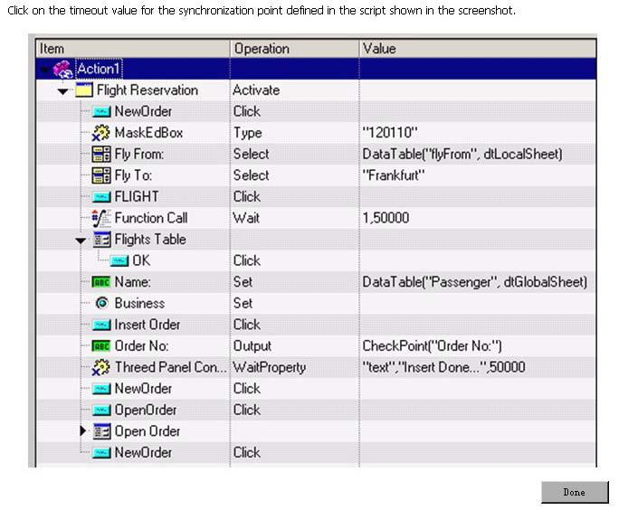
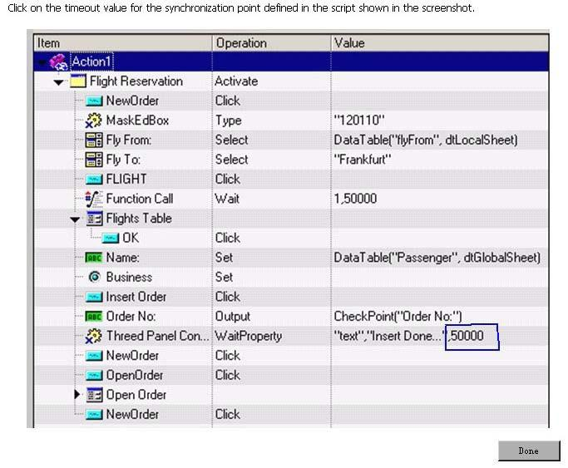
<<<<<< =================== >>>>>>
Q - 394: How does QuickTest Professional identify each object you record?
A. By class and properties
B. By class and methods
C. By methods and properties
D. By class only
<<<<<< =================== >>>>>>
Q - 395: Which term is used to define the name QuickTest Professional assigns is a recorded object?
A. Physical Name
B. Object Name
C. Repository Name
D. Logical Name
<<<<<< =================== >>>>>>
Q - 396: What is the best use of the Define New Test Object feature of the object repository?
A. To add a new object planned for your application
B. To add an object recently added to your application
C. To add an object you forgot to record
D. To add a new instance of a test object with properties that have changed
<<<<<< =================== >>>>>>
Q - 397: After regarding your test, you review the object repository and find three objects named button, button 1, and button 2. Which object repository feature enables you to identify the object in your application?
A. Locate in Application
B. Search in Repository
C. Highlight in Application
D. Identify in Application
<<<<<< =================== >>>>>>
Q - 398: Which step categories can be added using the Step Generator Tool? (Select three.)
A. Run-time objects
B. Default object types
C. Test objects
D. Utility objects
E. Data objects
F. Functions
<<<<<< =================== >>>>>>
Q - 399: Which item is used to identify the values captured by QuickTest during and used in a checkpoint as reference value during a test run?
A. Actual value
B. Expected value
C. Recorded value
D. Updated value
<<<<<< =================== >>>>>>
Q - 400: A QuickTest Professional automation benefit is the ability to increase test result reliability by checking visual cues. Which visual cue requires a tedious check in manual testing, but can be easily checked in QuickTest Professional?
A. Text attachment
B. Colors of a bitmap
C. Grayed-out field
D. Existence of a bitmap

Question No. | Correct Answer
Q. 391 | A,D
Q. 392 | A,B,G,H
Q. 393 | In Picture
Q. 394 | A
Q. 395 | D
Q. 396 | A
Q. 397 | C
Q. 398 | C,D,F
Q. 399 | B
Q. 400 | B

Q - 401 Click the exhibit Button
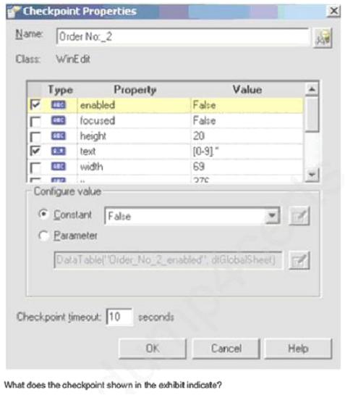
A The value of the field must not be numeric and the background is grayed out.
B. The value of the field must be an alphanumeric string beginning with a single numeric and the content can be edited.
C. The value of the field must be an alphanumeric string beginning with a single numeric and the content cannot be changed.
D.
The value of the field must be a single numeric and the background is grayed out.
<<<<<< =================== >>>>>>
Q - 402: How can you add a bitmap checkpoint after recording?
A. You access it from the Insert menu.
B. You use the right lick pop up an the Active Screen.
C. You manually add the checkpoint from the object repository.
D. You cannot add it after recording, orgy during recording.
<<<<<< =================== >>>>>>
Q - 403 Which QuickTest Professional feature can be applied to checkpoint and object property values to accommodate dynamic content in your application?
A. Constant expression
B. Substitute value
C. Regular expression
D. Timeout
<<<<<< =================== >>>>>>
Q - 404: You added parameters in your test and defined them in the Global and Local sheets. The Global sheet includes five rows and the Local sheet includes two rows. If you do not change any of the default Data Table run settings, how many Times will the test iterate?
A. 2
B. 5
C. 7
D. 10
<<<<<< =================== >>>>>>
Q - 405: The global Data Table for a test includes 200 rows. What is the best way to limit his test to only run one iteration?
A. By deleting all but one row from the global Data Table
B. By adding custom code b Expert View to limit the
terations
C. By right-clicking on the global Data Table to select he Iteration menu
D. By modifying he Faun options to Test Settings dialog
<<<<<< =================== >>>>>>
Q - 406: Click Next or More to continue. Click the Task button.
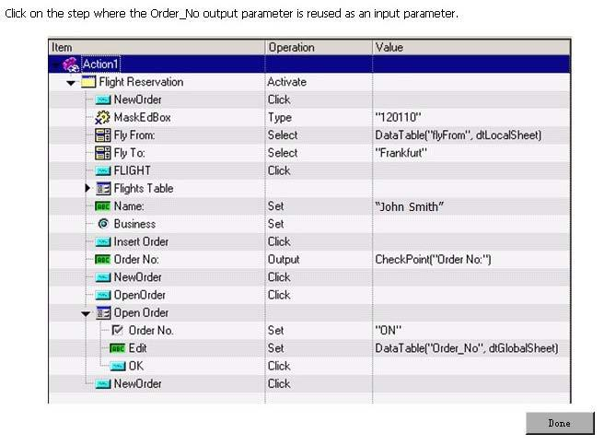
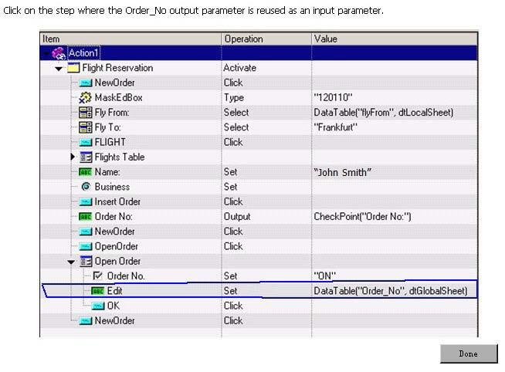
<<<<<< =================== >>>>>>
Q - 407: Which QuickTest Professional component can contain input data that can be used by any action in a lest?
A. Local data stet
B. Object repository
C. Runtime Data Table
D. Global data sheet
<<<<<< =================== >>>>>>
Q - 408: How can the Data Table be used in a custom checkpoint? (Select two.)
A. To store output values
B. To store input parameters
C. To use formulas
D. To access global values
E. To compare columns
<<<<<< =================== >>>>>>
Q - 409: Click Next or More to continue. Click the Task button.
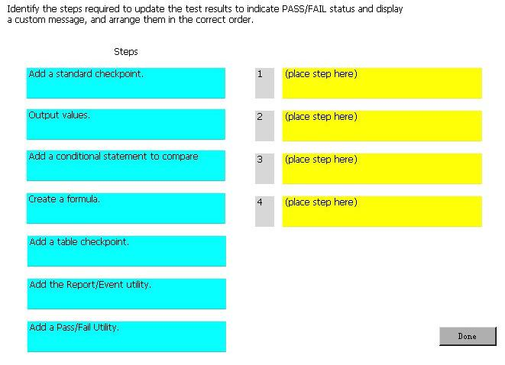
You have to validate the calculation of a check-out business process to confirm that the following formula is correct: QUANTITY * PRICE + TAX + SHIPPING = TOTAL
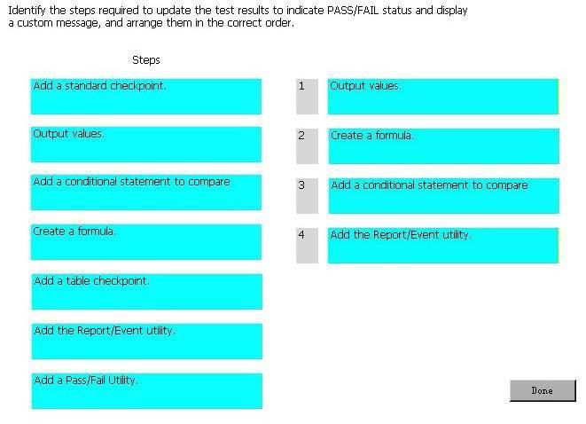
<<<<<< =================== >>>>>>
Q - 410: Which checkpoint type uses a query to validate expected value?
A. Standard
B. Table
C. Database
D. Text
Question No. | Correct Answer
Q. 401 | C
Q. 402 | B
Q. 403 | C
Q. 404 | B
Q. 405 | D
Q. 406 | In Picture
Q. 407 | D
Q. 408 | C,A
Q. 409 | In Picture
Q. 410 | C

Q - 411: What is compared in a bitmap checkpoint?
A. Bits
B. RGB
C. Pixels
D. Text
E. Jpegs
<<<<<< =================== >>>>>>
Q - 412: Which bitmap checkpoint feature allows the checkpoint to pass even if bitmaps are not identical?
<FONT< p=""></FONT<>
size=2 face=Arial>
A. Bit tolerance
B. RGB tolerance
C. BW tolerance
D. Image tolerance
<<<<<< =================== >>>>>>
Q - 413: How can you save a movie of the QuickTest playback?
A. Enable the System Monitor.
B. Enable the Movie Monitor.
C. Enable the Screen Recorder.
D. Enable the Playback Monitor.
<<<<<< =================== >>>>>>
Q - 414: You need to define a custom checkpoint for your test that will update the test results, but not cause the test to be marked as Pass or Fail. Which status value should you use?
A. micPass
B. rnicDone
C. miccomplete
D. micFail
<<<<<< =================== >>>>>>
Q - 415: A test comprises three sequential actions: action 1, action 2, and action 3. Action 3 is set to iterate on rows 1 through 3 and draws its data only from the global Data Table, which has 30 rows of data. The test, action2, and action 3 are set to iterate the default number of times. How many times will action 3 execute?
A. 3
B. 30
C. 33
D. 90
<<<<<< =================== >>>>>>
Q - 416: A team of testers created a library of reusable actions as building blocks for their automated test suite. One action, Fill Form, is referenced in a test called Submit Request. The owner of Fill Form needs to perform maintenance on it and is turning off its Reusable action property. When testers open the Submit Request test, how will they know that the Fill Form action is unavailable?
A. In the Missing Resources panel, Fill Form is listed with an explanation in the Details column.
B. In the Test Flow panel, the Fill Form is eyed out
C. When Submit Request is opened, QuickTest Professional pops up an informational message.
D. In the External Actions list in the Resources panel, Fill Form is grayed out.
<<<<<< =================== >>>>>>
Q - 417: In QuickTest Professional, how do you create independent or nested actions?
A. Highlight the step where you want the new action to start and perform Insert > Action > New Internal Action.
B. Highlight the step where you want the new action to start and select Edit > Action > Split Action.
C. Use Insert > Action > New Internal Action, and then copy and paste slaps from the old action to the new one.
D. Use Edit > Action > Split Action and copy and paste steps from the old action to the new one.
<<<<<< =================== >>>>>>
Q - 418: Which statement is true about an action's object repository?
A. An action is created with a separate local object repository.
B. An action uses the test's wasting local object repository by default.
C. An action must be associated with an object repository by the tester before it can be used.
D. An action is created with a copy of the test's local object repository.
<<<<<< =================== >>>>>>
Q - 419: When you use a local data sheet, what does Quick1est Professional use to determine how to run the test?
A. Only the run settings for the action
B. Only the run settings specified for t test
C. A combination of the rum settings for the lest and the action
D. The number of rows in the local Data Table
<<<<<< =================== >>>>>>
Q - 420: Which object repository types are supported by QuickTest Professional 10.0?
A. Local and shared
B. Lest and shared
C. Action and test
D. Action and shared
 | Question No. | Correct Answer
 | Q. 411 | C
 | Q. 412 | B
 | Q. 413 | C
 | Q. 414 | B
 | Q. 415 | B
 | Q. 416 | C
 | Q. 417 | B
 | Q. 418 | A
 | Q. 419 | C
 | Q. 420 | A

Q - 421: How do you associate an object repository with specific actions in a test?
A. Use the Resources panel to drag and drop repository icons on action icons.
B. Use the drag and drop option in the Object Repository Manager.
C. Use the Associates Repositories Tod.
D. Use the Resources window in the Test Settings dialog.
<<<<<< =================== >>>>>>
<FONT< p=""></FONT<>
color=#000080 size=2 face=Arial>
Q - 422: What is the result of merging two object repositories?
A. The primary repository is updated by default.
B. The tester may optionally choose to update the primary repository.
C. A third object repository is created.
D. The tester must select to create a third repository or update the primary repository.
<<<<<< =================== >>>>>>
Q - 423: Which steps are required to connect to Quality Center from QuickTest Professional? (Select three.)
A. Define a project
B. Connect to the server
C. Authenticate user
D. Create a user
E. Define a domain
F. Select a project
<<<<<< =================== >>>>>>
Q - 424:Which feature requires a connection to Quality Center?
A. Version Control
B. Jump to Step
C. System Monitor
D. Save Test with Resources
<<<<<< =================== >>>>>>
Q - 425: Identify QuickTest Professional resources. (Select three.)
A. Test versions
B. Actions
C. Checkpoints
D. Function libraries
E. Images
F. Recovery scenarios
<<<<<< =================== >>>>>>
Q - 426: Which menu option should you use to save your test to a version controlled Quality Center project for the first time?
A. Check-in
B. Save As
C. Save Test with Resources
D. Create Version
<<<<<< =================== >>>>>>
Q - 427: How do you initiate the Low Level Recording mode?
A. Click the Record button twice.
B. Activate Low Level Recording from the Automation menu.
C. Click Recd, press F8.
D. Click Record and activate Low Level Recording from the Automation menu.
<<<<<< =================== >>>>>>
Q - 428: Which feature can you use to teach QuickTest Professional to recognize any area of your application?
A. Object identification
B. Object wizard
C. Virtual objects
D. Virtual identification
<<<<<< =================== >>>>>>
Q - 429: Which events are considered exceptions when replaying a test? (Select two.)
A. Best application that crashes
B. Field is mandatory message
C. Printer out of ink message
D. invalid password message
E. invalid permission message
<<<<<< =================== >>>>>>
Q - 430: How can you pause and interact with the playback of a test?
A. Add a wait statement.
B. Add a breakpoint.
C. Add a delay.
D. Add a stop point.
 | Question No. | Correct Answer
 | Q. 421 | C
 | Q. 422 | C
 | Q. 423 | B,C,F
 | Q. 424 | A
 | Q. 425 | B,D,F
 | Q. 426 | B
 | Q. 427 | D
 | Q. 428 | C
 | Q. 429 | A,C
 | Q. 430 | B

Q - 431: Which tab in the Debug Viewer pane allows you to view or change variables or properties?
A. Watch
B. Variables
C. Command
D. View
<<<<<< =================== >>>>>>
Q - 432: Which Settings tab enables QuickTest Professional to measure the resources
being used by the application?
A. Resources
B. Environment
C. Local System Monitor
D. Run
<<<<<< =================== >>>>>>
Q - 433: How can you use monitors to cause the test to fail?
A. Add a monitor checkpoint.
B. Add custom code to evaluate monitor data.
C. Define a counter scale.
D. Define a monitor limit.
<<<<<< =================== >>>>>>
Q - 434: What can you do using the To Do pane? (Select two.)
A. Assign tasks to others.
B. Mark a task as In progress.
C. View TODO comments existing in the current test recovery scenarios.
D. Export TODO comments to comma-separated values or XML format.
E. View TODO comments existing in the current test checkpoints.
<<<<<< =================== >>>>>>
Q - 435: Where is the System Monitor tab located?
A. In the right pane of the Test Results window
B. In the Information pane
C. In the Resources pane
D. In the right pane of the System window
<<<<<< =================== >>>>>>
Q - 436: What happens when you import data from an external Excel file into the QuickTest Professional Data Table?
A. Row data is overwritten when column headers in Excel and the Data Table match.
B. A new column is added to the Data Table when column headers in Excel and the Data Table match.
C. All the sheets in the Excel file are imported.
D. Excel listboxes are expanded and one row is added to the Data Table per value in the list.
<<<<<< =================== >>>>>>
Q - 437: Which statement should you use to export all sheets in the Data Table?
A. DataTable.Export ("C:flights.xls")
B. DataTable.ExportSheet ("Cflights.xls.", ALL)
C. DataTable.ExportAllSheets ("C:flights.xls")
D. DataTable.Export ("C:flights.xls" , ALL)
<<<<<< =================== >>>>>>
Q - 438: Which statement will retrieve the test object's properties during the test run?
A. iCount = WebRadioGroup("seat").GetROProperty("Items Count")
B. WebRadioGroup("seat).CheckProperty("Items Count")
C. oDesc = WebTable("Firstname").GetTOProperties
D. propsList = WebTable("FirstName").ChildObjects(oDesc)
<<<<<< =================== >>>>>>
Q - 439: Which method retrieves a property of a runtime object?
A. GetROProperty
B. GetTOProperty
C. GetRuntimeProperty
D. GetRTProperty
<<<<<< =================== >>>>>>
Q - 440: In the test results, what do square brackets around a test object name indicate?
A. The test object was created dynamically during the run session using a programmatic description or the ChildObjects method.
B. Smart Identification was invoked for that object during the test run.
C. The Create method was used at runtime to dynamically create the referenced object.
D. This is an optional step.
 |  | Question No. |  |  |  | Correct Answer
 |  | Q. 431 |  |  |  | A
 |  | Q. 432 |  |  |  | C
 |  | Q. 433 |  |  |  | D
 |  | Q. 434 |  |  |  | A,D
 |  | Q. 435 |  |  |  | A
 |  | Q. 436 |  |  |  | C
 |  | Q. 437 |  |  |  | A
 |  | Q. 438 |  |  |  | C
 |  | Q. 439 |  |  |  | A
 |  | Q. 440 |  |  |  | A
Q - 441: Why would a tester use the Description object in the Expert View of a test?
A. To programmatically modify a test object's definition directly in the object repository
B. To bypass the object repository when identifying an object at runtime
C. To data-drive logical names and make the test more generic
D. To make it easier to retrieve child objects using the ChildObjects method
<<<<<< =================== >>>>>>
<FONT< p=""></FONT<>
size=2 face=Arial>
Q - 442: Which language is used for Expert View?
A. TSL
B. VB
C. VBScript
D. Python
<<<<<< =================== >>>>>>
Q - 443: What does the dot indicate in VBScript? (Select two.)
A. Property
B. Child object
C. Statement
D. Function
E. Method
<<<<<< =================== >>>>>>
Q - 444: What do you use to create a programmatic description? (Select two.)
A. Property and method
B. Property and value
C. ":" with the logical name
D. Programmatic object
E. Description object
<<<<<< =================== >>>>>>
Q - 445: The following statement is causing your test run to fail with a syntax error:newString = "Passenger " & 1Which function do you need to add to this statement so the correct output of newString is "Passenger 1"?
A. Mod(1)
B. ToString1)
C. clnt(1)
D. cStr(1)
<<<<<< =================== >>>>>>
Q - 446: Which DataTable method makes an external spreadsheet available to QuickTest Professional?
A. GetSheet
B. OpenSheet
C. ImportSheet
D. ExportSheet
<<<<<< =================== >>>>>>
Q - 447: Which names are used to identify the status of your application before and after your automated test executes? (Select two.)
A. Initial condition
B. Static state
C. End condition
D. Down condition
E. Done condition
<<<<<< =================== >>>>>>
Q - 448: What are the default add-ins installed with QuickTest Professional? (Select three.)
A. .NET
B. ActiveX
C. HTML
D. Web
E. Java
F. OCX
G. Visual Basic
<<<<<< =================== >>>>>>
Q - 449: Which Quick Test Professional View Option will show you the repositories associated with each action?
A. Resources
B. Information
C. Script Repository
D. Active Screen
<<<<<< =================== >>>>>>
Q - 450: Where can you reset the add-in manager if it does not display when you launch QuickTest Professional?
A. General Options
B. Run Options
C. Test Properties
D. Test Settings
 | Question No. |  |  | Correct Answer
 | Q. 441 |  |  | B
 | Q. 442 |  |  | C
 | Q. 443 |  |  | B,E
 | Q. 444 |  |  | B,E
 | Q. 445 |  |  | D
 | Q. 446 |  |  | C
 | Q. 447 |  |  | A,C
 | Q. 448 |  |  | B,D,G
 | Q. 449 |  |  | A
 | Q. 450 |  |  | A

Q - 451: You set your Record and Run settings to Record, and then run a test on any open browser. Which applications will be recorded? (Select two.)
A. Firefox
B. Safari
C. Silverlight
D. Chrome
E. Internet Explorer
<<<<<< =================== >>>>>>
Q
- 452: Click Next or More to continue. Click the Task button.
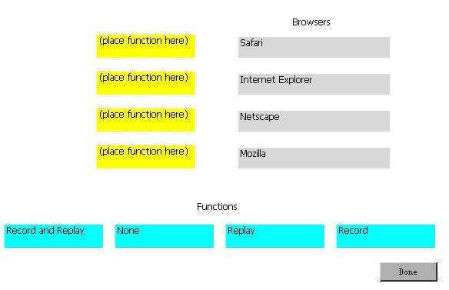
You have set your Record and Run settings to Record and run tests on any open browser. Indicate the function that works for each browser.
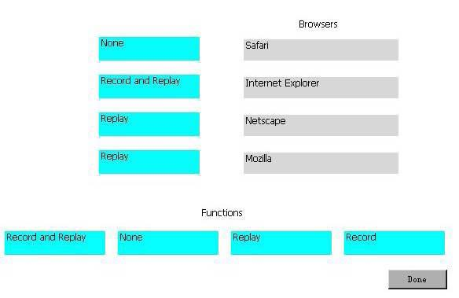
<<<<<< =================== >>>>>>
Q - 453: Which directory is the default directory in the QuickTest Professional file structure where the local Data Table is located?
A. Action 0 folder
B. Local Action folder
C. Default Test folder
D. Data folder
<<<<<< =================== >>>>>>
Q - 454: Which QuickTest Professional menu item should you use when emailing a QuickTest Professional test to another tester?
A. Send Email...
B. Export Test to Zip File...
C. Save Test with Resources...
D. Export Test and Email...
<<<<<< =================== >>>>>>
Q - 455: You have defined a global synchronization timeout of 30 seconds for your test. The synchronization point timeout for a button to become enabled is set to 10000.
During playback of the script, what is the maximum amount of time QuickTest Professional will wait for the button to become enabled?
A. 10 seconds
B. 30 seconds
C. 40 seconds
D. 10030 seconds
<<<<<< =================== >>>>>>
Q - 456: Which QuickTest Professional feature should you use to view methods and properties of objects in your application?
A. Spy Object
B. Object Repository
C. Object Spy
D. Object Viewer
<<<<<< =================== >>>>>>
Q - 457: Which object repository type is created by default?
A. Shared
B. Reusable
C. Local
D. Global
<<<<<< =================== >>>>>>
Q - 458: You need to change the properties of an object in your object repository. Which repository feature enables you to quickly access the specific item if your repository contains hundreds of objects?
A. Highlight in Application
B. Search in Repository
C. Identify in Repository
D. Locate in Repository
<<<<<< =================== >>>>>>
Q - 459: Which QuickTest Professional feature confirms that the application is functioning correctly?
A. Parameterization
B. Checkpoint
C. Breakpoint
D. Validation
<<<<<< =================== >>>>>>
Q - 460: Which statement type can you use in your test to wait for a condition to be met and fail the test if it times out before meeting the condition?
A. Pause method
B. Exist method
C. Standard checkpoint
D. Wait statement
 |  |  |  | Question No. |  |  |  |  |  | Correct Answer
 |  |  |  | Q. 451 |  |  |  |  |  | A,E
 |  |  |  | Q. 452 |  |  |  |  |  | In Picture
 |  |  |  | Q. 453 |  |  |  |  |  | C
 |  |  |  | Q. 454 |  |  |  |  |  | B
 |  |  |  | Q. 455 |  |  |  |  |  | C
 |  |  |  | Q. 456 |  |  |  |  |  | C
 |  |  |  | Q. 457 |  |  |  |  |  | C
 |  |  |  | Q. 458 |  |  |  |  |  | D
 |  |  |  | Q. 459 |  |  |  |  |  | B
 |  |  |  | Q. 460 |  |  |  |  |  | C
Q - 461: Click Next or More to continue. Click the Task button.
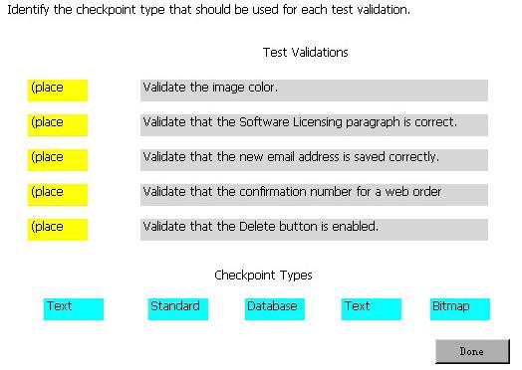
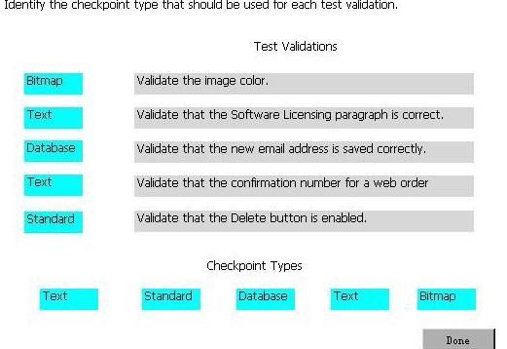
<<<<<< ===================
>>>>>>
Q - 462: Which checkpoint type should you use to validate the enabled state of a button?
A. Text
B. Standard
C. Bitmap
D. XML
<<<<<< =================== >>>>>>
Q - 463: Which term is used to define a string of special characters that define the condition of the search?
A. Constant expression
B. Placeholder
C. Regular expression
D. Parameter
<<<<<< =================== >>>>>>
Q - 464: You have multiple test cases that require you to test valid and invalid username and password combinations. Which parameter type should you use?
A. Output
B. Input
C. Random Number
D. Environment
<<<<<< =================== >>>>>>
Q - 465: Where is data for an Input parameter stored?
A. Run-time Data Table
B. Design-time Data Table
C. Run-time Data Repository
D. Design-time Data Repository
<<<<<< =================== >>>>>>
Q - 466: User-defined environment variables can be imported from an external file. What is the valid file type that can be imported?
A. txt
B. xml
C. csv
D. html
<<<<<< =================== >>>>>>
Q - 467: After playing back a test containing output values, where can the output values be viewed?
A. Global Data Table
B. Local Data Table
C. Design-time Data Table
D. Run-time Data Table
<<<<<< =================== >>>>>>
Q - 468: Which status is reported in the Test Results Summary if the test does not include checkpoints?
A. Fail
B. Passed
C. Done
D. Complete
<<<<<< =================== >>>>>>
Q - 469: You ran a test scenario with 10 iterations. What does the Test Results Summary report if 8 iterations pass and 2 iterations fail?
A. The summary reports PASS because more iterations passed than failed.
B. The summary reports the status for each iteration.
C. The summary reports DONE.
D. The summary reports FAIL because all iterations did not pass.
<<<<<< =================== >>>>>>
Q - 470: A tester uses QuickTest Professional connected to Quality Center and the tests are stored in Quality Center. At an upcoming conference, this tester wants to demonstrate a new QuickTest Professional test.
The test makes calls to reusable actions from other QuickTest Professional tests stored in Quality Center.
What is the simplest way to make the test portable so it can run disconnected from Quality Center?
A. Use the QuickTest Professional Save test with resources feature.
B. Change the calls to the reusable actions, use copies of the reusable actions, and then use the QuickTest Professional Save test with resources feature.
C. Use the QuickTest Professional Save test with resources feature for main test and do the same for the test that contains the called reusable actions.
D. Use the QuickTest Professional Export to zip feature.
 |  |  | Question No. |  |  | Correct Answer
 |  |  | Q. 461 |  |  | In Picture
 |  |  | Q. 462 |  |  | B
 |  |  | Q. 463 |  |  | C
 |  |  | Q. 464 |  |  | B
 |  |  | Q. 465 |  |  | B
 |  |  | Q. 466 |  |  | B
 |  |  | Q. 467 |  |  | D
 |  |  | Q. 468 |  |  | C
 |  |  | Q. 469 |  |  | B
 |  |  | Q. 470 |  |  | A
Q - 471: What happens when a tester performs an Insert > Call to Copy of Action?
A. The local Data Table and the run iterations settings (in action call properties) are copied over.
B. The steps, checkpoints, parameterizations, action parameters, and object repository are all copied over.
C. Only the called action, but none of its child actions (that is, actions called by it), is copied over.
D. The Use data stored with the original action is disabled.
<<<<<<
=================== >>>>>>
Q - 472: Which feature displays all the test's actions?
A. Actions tree within the Resources panel
B. Test Flow panel
C. Flow Viewer panel
D. Test Action Manager Tool
<<<<<< =================== >>>>>>
Q - 473: Where are the local data sheet iterations specified?
A. Test Run Properties
B. Action Settings
C. Action Call Properties
D. Test Flow Settings
<<<<<< =================== >>>>>>
Q - 474: When inserting a call to a reusable action, how are the data resources in that action handled?
A. The data continues to be stored with the original action (read-only) and the new action refers to it.
B. A copy of the data is made (editable) and stored with the new action.
C. The tester must make a one-time selection to either copy the data or refer to the original data.
D. The tester always has the option to copy the data or refer to the original data.
<<<<<< =================== >>>>>>
Q - 475: Where do you go to modify a shared object repository?
A. Resources > Object Repository Manager
B. Resources > Object Repository
C. Tools > Object Repository Manager
D. Tools > Resources Manager > Object Repository
<<<<<< =================== >>>>>>
Q - 476: Which QuickTest Professional tool uses the Object Repositories Merge Tool?
A. Map Repository Parameters Tool
B. Update from Local Repository Tool
C. Object Repository Comparison Tool
D. Update from Application Tool
<<<<<< =================== >>>>>>
Q - 477: Which conflicts does the Objects Repositories Merge Tool detect? (Select three.)
A. Same object different parent
B. Same name different description
C. Same description different name
D. Same name extra properties
E. Similar description
<<<<<< =================== >>>>>>
Q - 478: Click Next or More to continue. Click the Task button.
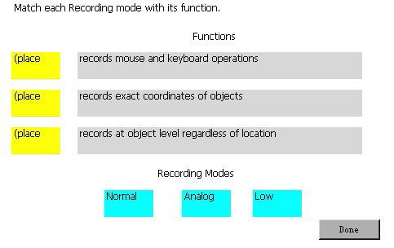
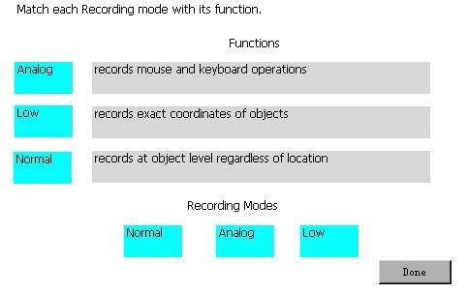
<<<<<< =================== >>>>>>
Q - 479: Click the Exhibit button.
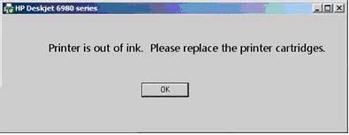
You are creating a recovery scenario to handle the pop-up shown in the exhibit. Which recovery option should you select?
A. Keyboard or mouse operation
B. Close application process
C. Function call
D. Restart Microsoft Windows
<<<<<< =================== >>>>>>
Q - 480: What is the correct syntax for a programmatic description?
A. WebEdit("Name:=Author" , Index:=3)
B. WebEdit("Name:=Author" , "Index:=3")
C. WebEdit("Name:=Author";"Index=3")
D. WebEdit("Name:=Author";"Index:=3)
 | Question No. |  |  |  | Correct Answer
 | Q. 471 |  |  |  | B
 | Q. 472 |  |  |  | B
 | Q. 473 |  |  |  | C
 | Q. 474 |  |  |  | D
 | Q. 475 |  |  |  | A
 | Q. 476 |  |  |  | B
 | Q. 477 |  |  |  | B,C,E
 | Q. 478 |  |  |  | In Picture
 | Q. 479 |  |  |  | A
 | Q. 480 |  |  |  | B

Q - 481: When is it best to use a programmatic description?

A. When you work with properties and methods of an object not in the object repository
B. When you are retrieving a property from a static run-time object
C. When you are retrieving a property from a test object
D. When you need to click static buttons

<<<<<< =================== >>>>>>

Q - 482: Which operator do you use to concatenate two strings in VBScript?

A. &
B. &&
C. concat
D. ++

<<<<<< =================== >>>>>>
New Set of Questions Begin from Here

Q - 483: What is the purpose of the Data Table in a custom checkpoint?

A. To store output values and formulas
B. To compare headers
C. To access global values
D. To store input objects
<<<<<< =================== >>>>>>

Q - 484: In HP QuickTest Professional, what does the Managing Versions feature enable you to
A. Compare different test results
B. Check out only the latest version of an asset
C. Compare only the latest two versions of an asset
D. Check in only the latest version of an asset

<<<<<< =================== >>>>>>

Q - 485: You have developed a functional test in HP QuickTest Professional and want to take advantage of version control in HP Application Lifecycle Management.
Which menu option should you use to put your test in HP Application Lifecycle Management?

A. Save As
B. Create Version
C. Check-in
D. Save Test with Resources

<<<<<< =================== >>>>>>

Q - 486: What happens when you import data using the DataTable.ImportSheet function?
A. Data is overwritten when column headers in Excel and the data table match.
B. Sheet in the Excel file is always imported.
C. Data will be appended to the data table.
D. A new column is added to the data table when column headers in Excel and the data table match.

<<<<<< =================== >>>>>>

Q - 487: HP QuickTest Professional 11 enables you record steps from which browser?
A. Chrome
B. Safari
C. Netscape
D. Firefox

<<<<<< =================== >>>>>>

Q - 488: Which Web testing capabilities have been added in HP QuickTest Professional 11? (Select three.)

A. Firefox Document Object Model access
B. Internet Explorer Developer Toolbar support
C. Event Identifiers that enable identification based on events associated to a Web object
D. Javascript code capability that enables lavascript code to be embedded in all loaded browser pages
E. Property Identifiers that enable identification based on properties associated to a Web object
F. Vbscript code capability that enables Vbscript code to run in specific browser pages

<<<<<< =================== >>>>>>

Q - 489: What is created when you select Edit > Action > Split Action?
A. An independent action
B. A new shared object repository
C. An action fork
D. A new test

<<<<<< =================== >>>>>>

Q - 490: When inserting a call to a reusable action, which two ways can the tester handle the data resources in that action? (Select two.)

A. Have the new action refer to a read-only copy of the data in the original action.
B. Have the action get an empty set of data resources.
C. Delete the data.
D. Store an editable copy of the data in the new action.
E. Have the new action refer with write permissions to the copy of the data in the original action.

Question No. | Correct Answer
Q. 481 | A
Q. 482 | A
Q. 483 | A
Q. 484 | B
Q. 485 | A
Q. 486 | A
Q. 487 | D
Q. 488 | A,C,D
Q. 489 | A
Q. 490 | A,D

Q - 491: A HP QuickTest Professional instructor needs to take a sample test that was built in HP Application Lifecycle Management to an off-site training facility.
What is the simplest way to convert that test into a portable format?

A. Use the Export to Portable feature to export the test with its object repository into XML format.
B. Use the Save Test with Resources feature for main test and do the same for the test that contains the called reusable actions.
C. Use the Save Test with Resources feature.
D. Use the Export to Zip feature.

<<<<<< =================== >>>>>>

Q - 492: What is configured with the Action Call Properties dialog box?
A. Object repositories
B. Test flow settings
C. Test run properties
D. Local data sheet iterations

<<<<<< =================== >>>>>>

Q - 493: A test, EditShoppingCart, has a call to an external action, SaveCart. The owner of SaveCart needs to perform maintenance on it and has turned off its Reusable property.
When testers open the EditShoppingCart test, how will they know that the SaveCart action is unavailable?

A. SaveCart is listed with an explanation in the Details column in the Missing Resources panel.
B. HP QuickTest Professional pops up an informational message when EditShoppingCart is opened.
C. SaveCart is grayed out in the Test Flow panel.
D. SaveCart is grayed out in the External Actions list in the Resources panel.

<<<<<< =================== >>>>>>

Q - 494: HP QuickTest Professional supports which kinds of Object Repositories? (Select two.)

A. Global
B. Shared
C. Test
D. Action
E. Local

<<<<<< =================== >>>>>>

Q - 495: Which types of conflicts does the Objects Repositories Merge Tool detect?
A. Same name different description, similar description
B. Same name extra properties, different name same properties
C. Same name different parent, same parent different name
D. Same object different parent, similar description

<<<<<< =================== >>>>>>

Q - 496: Which menu is used to access the Object Repository Manager to modify a shared object repository?

A. Resources
B. File
C. Edit
D. Tools

<<<<<< =================== >>>>>>

Q - 497: Which access does a newly purchased HP Functional Testing license provide?
A. Only HP QuickTest Professional
B. Only HP QuickTest Professional and its Add-ins
C. Service Test, HP QuickTest Professional and its Add-ins
D. Functional Testing License Server Console, HP QuickTest Professional and its Add-ins

<<<<<< =================== >>>>>>

Q - 498: Which statement is true about HP QuickTest Professional (QTP) software update processes? (Select two.)

A. You can manually check for updates using the Updater Tool and then optionally download and install them.
B. You can manually check for updates within QTP by selecting Help > HP Update, and then optionally download and install them.
C. QTP automatically checks for updates when it is started and automatically applies them.
D. You can manually check for updates within QTP by selecting Start > Programs > HP QuickTest Professional > HP Update, and then optionally download and install them.
E. QTP automatically checks for updates once every 30 days and automatically applies them, by default.

<<<<<< =================== >>>>>>

Q - 499: What is one purpose of virtual objects?
A. To point to an object name that might be located in any object repository
B. To map an area of your application to a standard class
C. To utilize an object without pre-defining the object type
D. To point to an object that will be defined later, possibly by another tester

<<<<<< =================== >>>>>>

Q - 500: How is the Low Level Recording mode initiated?
A. By clicking Tools > Automation menu > Activate Low Level Recording
B. By clicking Record and pressing F8
C. By clicking the Record button twice
D. By clicking Record and selecting it from the Automation menu

Question No. | Correct Answer
Q. 491 | C
Q. 492 | D
Q. 493 | B
Q. 494 | B,E
Q. 495 | A
Q. 496 | A
Q. 497 | B
Q. 498 | B,D
Q. 499 | B
Q. 500 | D

Q - 501: Where can a new Extensibility support set be activated after its deployment to HP QuickTest Professional?

A. The Add-in manager, which displays the name of the new Extensibility support set as an additional Add-in, under the Web Add-in
B. The Add-in manager, which displays the name of the new Extensibility support set as an additional independent Add-in
C. The Record and Run Settings dialog box, which displays the name of the new Extensibility support set as an additional option in the Web tab
D. The Resources pane, which displays the name of the new Extensibility support set as an additional node in the Resources tree

<<<<<< =================== >>>>>>

Q - 502: Which public toolkits are supported by the Web Add-in Extensibility feature? (Select four.)

A. ASP.N ET AJAX
B. FOX
C. SUN JWDK
D. Motif
E. Google Web Toolkit
F. YahooUl
G. Dojo
H. COM.NET AJAX

<<<<<< =================== >>>>>>

Q - 503: How does the HP QuickTest Professional Web Add-in Extensibility feature improve browser independent support?

A. It supports testing custom controls on both Internet Explorer and Firefox, and on different versions of these browsers.
B. It extends Web testing support to Google Chrome and its different versions.
C. It supports testing custom controls on different versions of Internet Explorer only.
D. It supports browser independent web testing by replacing the Web Add-in.

<<<<<< =================== >>>>>>

Q - 504: Which recovery option is best for a pop-up message that states "Printer is out of ink"?
A. Close application process
B. Function call
C. Restart Microsoft Windows
D. Keyboard or mouse operation

<<<<<< =================== >>>>>>

Q - 505: What are prerequisites for using Log Tracking? (Select two.)

A. The log framework must include an UDP appender.
B. The log files must be placed in a test directory.
C. The test must support log tracking statements.
D. All the Optional Steps must be disabled.
E. The tested application must use Java or.NET log framework.

<<<<<< =================== >>>>>>

Q - 506: Which data table method can retrieve data from an Excel file?
A. OpenSheet
B. ExportSheet
C. ImportSheet
D. GetSheet

<<<<<< =================== >>>>>>

Q - 507: Which HP QuickTest Professional feature enables you to track application performance counters during a run session?

A. Environment Monitor
B. Local System Monitor
C. Resource counters
D. Run Viewer

<<<<<< =================== >>>>>>

Q - 508: You have created a Bitmap checkpoint and want to allow a certain degree of difference between a stored expected image and an image from the AUT and still consider it a PASS.
Which checkpoint feature should you use?

A. RGB tolerance
B. BW tolerance
C. Image tolerance
D. Bit tolerance

<<<<<< =================== >>>>>>

Q - 509: Which type of checkpoint compares pixel values?
A. XML
B. Visual
C. Graphical
D. Standard
E. Bitmap

<<<<<< =================== >>>>>>

Q - 510: What is the purpose of the GetROProperty method?
A. To retrieve a property value of a runtime object
B. To retrieve a property of a test object
C. To retrieve a property value of a test object
D. To retrieve a property of a repository object

Question No. | Correct Answer
Q. 501 | A
Q. 502 | A,E,F,G
Q. 503 | A
Q. 504 | D
Q. 505 | A,E
Q. 506 | C
Q. 507 | B
Q. 508 | A
Q. 509 | B
Q. 510 | A

Q - 511: What are two HP QuickTest Professional resources?
A. Recovery Scenarios and Images
B. Checkpoints and Test Versions
C. Images and Checkpoints
D. Function Libraries and Recovery Scenarios

<<<<<< =================== >>>>>>

Q - 512: How can you add or change recordable or non-recordable operations to your test? (Select three.)

A. Drag objects from the Available Keywords pane.
B. Drag objects from the data table or insert from a shared repository.
C. Change the operation in the Keyword View.
D. Drag objects from Available Keywords or from the Active Screen.
E. Use the Step Generator or insert through Keyword View.
F. Add an operation in the Recording Option Manager.

<<<<<< =================== >>>>>>

Q - 513: What is the purpose of the Visual Relation Identifier?
A. It allows identification of objects, based on mapping of the Object Hierarchy to the AUT.
B. It allows identification of objects, based on sorting of objects on the AUT in a specific order.
C. It allows identification of objects, based on mapping to specific default classes.
D. It allows identification of objects, based on their neighboring objects.

<<<<<< =================== >>>>>>

Q - 514: How does HP QuickTest Professional identify each object you record? (select two.)

A. By class
B. By properties
C. By methods
D. By conditions
E. By actions

<<<<<< =================== >>>>>>

Q - 515: DRAG DROP : Click the Task button. Place the methods for identifying an object in the order in which QTP would attempt to use tem Assume they are all defined/enabled.
Place the methods for identifying an object in the order in which QTP would attempt to use them. Assume they are all defined / enabled.
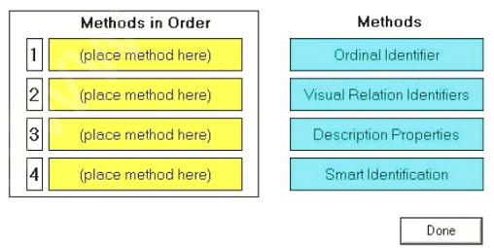
Answer
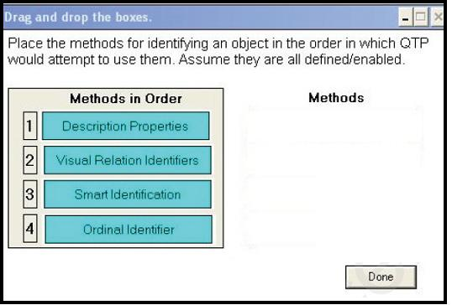
<<<<<< =================== >>>>>>

Q - 516: Using a default installation of HP QuickTest Professional, which type of Object Repository stores objects when they are created?

A. Reusable
B. Global
C. Local
D. Shared

<<<<<< =================== >>>>>>

Q - 517: After recording a test, you find an object in the Object Repository named AppResult_1.
Which Object Repository feature allows you to search for this object in your application?

A. Search in Repository
B. Highlight in Application
C. Locate i n Application
D. Find in Application

<<<<<< =================== >>>>>>

Q - 518: DRAG DROP: Click the Task button. Match the icons in the Object Spy dialog box with their descriptions. Note: Icons may be used more than once.
Match the icons in the Object Spy dialog box with their descriptions.
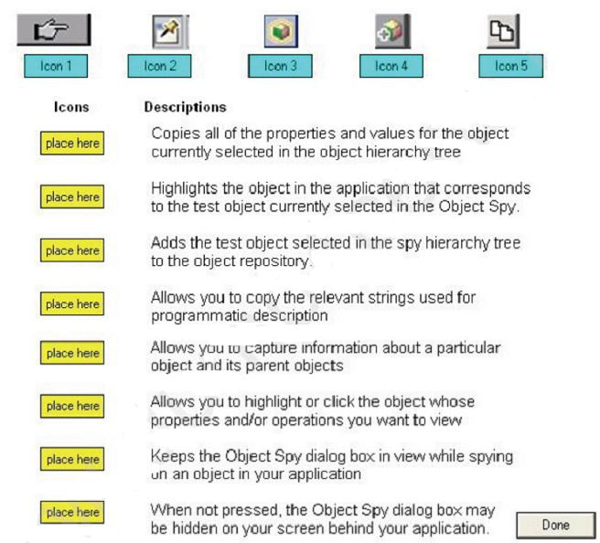
Answer
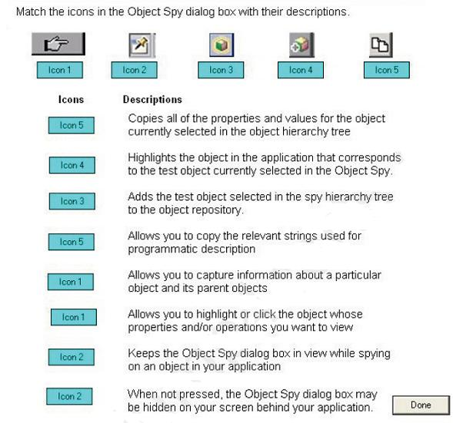
<<<<<< =================== >>>>>>

Q - 519: What is a logical name in HP QuickTest Professional?
A. The name assigned to a recorded object
B. The attached text of the test object
C. The name of a logical test condition
D. The name of the Object Repository

<<<<<< =================== >>>>>>

Q - 520: What can a dot indicate in VBScript? (Select three.)
A. A method
B. A description
C. A property
D. A function argument
E. A child object
F. An end of statement
Question No. | Correct Answer
Q. 511 | A
Q. 512 | A,C,E
Q. 513 | D
Q. 514 | A,B
Q. 515 | In Picture
Q. 516 | C
Q. 517 | B
Q. 518 | In Picture
Q. 519 | A
Q. 520 | A,C,E

Q - 521: Which feature of HP QuickTest Professional displays VBScript code?
A. Programmatic Description
B. Expert View
C. Keyword View
D. Object Editor

<<<<<< =================== >>>>>>

Q - 522: Which statement is true about a Database checkpoint?
A. It checks the state of an object property.
B. It checks for a parameterized property value.
C. It uses a query to validate actual value.
D. It checks for a constant property value.

<<<<<< =================== >>>>>>

Q - 523: Which option can be selected in the Active Screen Options tab?
A. Display the Active Screen
B. Save window layout
C. Display test report after test run
D. Change the capture level

<<<<<< =================== >>>>>>

Q - 524: What are the default Add-ins installed with HP QuickTest Professional?
A. ActiveX and Web
B. OCX and XML
C..NET and HTML
D. Visual Basic and Java

<<<<<< =================== >>>>>>

Q - 525: What is stored in the Default Test folder using the default HP QuickTest Professional folder structure? (Select two.)

A. Local Data Table
B. Run-time Data Table
C. Action0 folder
D. Local Action folder
E. Data folder

<<<<<< =================== >>>>>>

Q - 526: You have defined a global synchronization timeout of 30 seconds for your test. The synchronization point timeout for a button to become enabled is set to 30,000.
During playback of the script, what is the maximum amount of time HP QuickTest Professional will wait for the button to become enabled?

A. 30 seconds
B. 33 seconds
C. 60 seconds
D. 30,030 seconds

<<<<<< =================== >>>>>>

Q - 527: Which feature of the Object Repository allows you to add a new object planned for your application?

A. Add New Test Object
B. Specify New Test Object
C. Record New Test Object
D. Define New Test Object

<<<<<< =================== >>>>>>

Q - 528: What is displayed in the HP QuickTest Professional Keyword View?
A. The active screen during the test run
B. Keywords used in the initial and end conditions
C. Associated functions available to the action
D. The recorded steps in graphical format

<<<<<< =================== >>>>>>

Q - 529: In the test results, square brackets around a test object name indicate that the test object was dynamically created using which functions? (Select two.)

A. Child Objects method
B. Smart Identification
C. DynamicBuild method
D. Create method
E. Programmatic Description

<<<<<< =================== >>>>>>

Q - 530: Where should an output parameter be saved for reuse?
A. Run-time data table
B. Design-time data table
C. Design-time data repository
D. Run-time data repository

Question No. | Correct Answer
Q. 521 | B
Q. 522 | C
Q. 523 | D
Q. 524 | D
Q. 525 | C,D
Q. 526 | C
Q. 527 | D
Q. 528 | D
Q. 529 | A,E
Q. 530 | B

Q - 531: You added parameters in your test and defined them in the Global and Local sheets. The Global sheet includes two rows, and the Local sheet includes five rows.
If you do not change any of the default data table run settings, how many times will the test iterate?

A. 2
B. S
C. 7
D. 10

<<<<<< =================== >>>>>>

Q - 532: The global data table for a test includes 50 rows. What is the best way for you to limit this test to only run five iterations?

A. Delete all but five rows from the run-time Data Table.
B. Add custom code to Expert View to limit the iterations.
C. Disable all but five of the rows.
D. Modify the Run options to Test Settings dialog.

<<<<<< =================== >>>>>>

Q - 533: What does the Automatically Parameterizing Steps feature enable you to do?
A. Generate random parameter values for each action in a test
B. Perform automatic parameterization of all relevant steps in any action in a test
C. Create test steps automatically in any action in a test
D. Link parameters to test requirements in any action in a test

<<<<<< =================== >>>>>>

Q - 534: What does the Watch tab enable you to do?
A. View only the variable value
B. Evaluate a VBScript expression
C. View the dimension in Byte of the selected variable
D. Erase a local variable

<<<<<< =================== >>>>>>

Q - 535: What can be added to pause a test run at a specific step?
A. Breakpoint
B. Delay
C. Stop point
D. Sync statement

<<<<<< =================== >>>>>>

Q - 536: What is used to create a Dynamic Programmatic Description?
A. Description object, property, and value
B. Programmatic object, description, and property
C. Programmatic object, method, and ":" in the logical name
D. Property, method, and value

<<<<<< =================== >>>>>>

Q - 537: Which type of object is best handled with a Programmatic Description?
A. A static runtime object
B. A test object
C. An object not in the Object Repository
D. A static button

<<<<<< =================== >>>>>>

Q - 538: Which options are available for the Screen Recorder feature? (Select two.)

A. Capture a movie only for the failed steps
B. Capture a movie of all steps in the recording stage
C. Capture a movie only of selected test runs
D. Capture a movie of all steps in the run
E. Capture a movie only of selected page

<<<<<< =================== >>>>>>

Q - 539: What is available in the Executive Summary section of the Run Result pane? (Select two.)

A. A graphical representation of the results
B. The Pass/Fail test status
C. The test parameters value
D. A still image of the state of the application at a particular step
E. The total run execution time

<<<<<< =================== >>>>>>

Q - 540: Which pane in the Run Result window should you use to compare test results across different test runs?

A. Captured Data pane
B. Compare Results pane
C. Statistics pane
D. Executive Summary pane
Question No. | Correct Answer
Q. 531 | A
Q. 532 | D
Q. 533 | B
Q. 534 | B
Q. 535 | A
Q. 536 | A
Q. 537 | C
Q. 538 | A,D
Q. 539 | B,E
Q. 540 | C

Q - 541: Which HP QuickTest Professional feature can be installed as a standalone application?
A. Run Result Viewer
B. Object Repository Manager
C. Log Tracking Manager
D. Object Spy

<<<<<< =================== >>>>>>

Q - 542: You have configured a test without checkpoints. After a successful test run with no failures, which status is displayed in the Test Results Summary?

A. Passed
B. Done
C. Successful
D. Complete

<<<<<< =================== >>>>>>

Q - 543: Which conditions cause Smart Identification to fail? (Select two.)

A. Multiple objects match the learned description.
B. No object matches the learned description.
C. No methods match the learned description.
D. Multiple methods match the learned description.
E. An element does not support Smart Identification.

<<<<<< =================== >>>>>>

Q - 544: DRAG DROP: Click the Task button. Identify the valid steps of the Smart Identification process and place them in the correct order of execution.
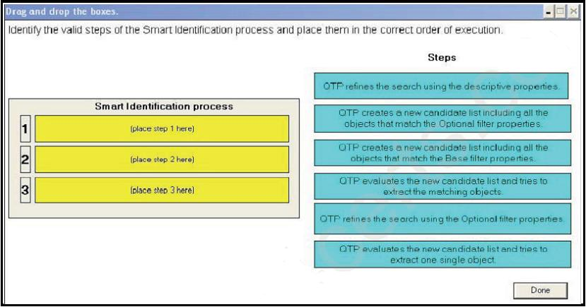
Answer
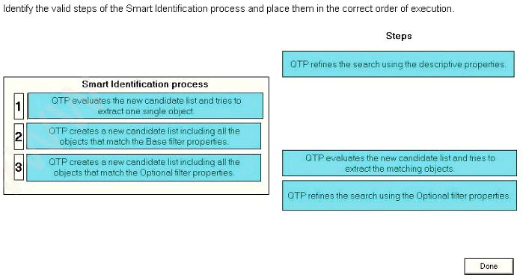
<<<<<< =================== >>>>>>

Q - 545: Which feature requires a connection to HP Application Lifecycle Management?
A. Jump to Step
B. Baselining
C. System Monitor
D. Save Test with Resources

<<<<<< =================== >>>>>>

Q - 546: Which steps are required to connect to HP Application Lifecycle Management from HP QuickTest Professional? (Select three.)

A. Define a project
B. Connect to the server
C. Authenticate user
D. Create a user
E. Define a domain
F. Select a project

<<<<<< =================== >>>>>>

Q - 547: Before automating a test, you decide to create a library of actions to be reused to achieve testing goals.
Which elements are critical for recording the different combinations of actions?

A. Starting and ending parameters
B. Input and output conditions
C. Initial and end conditions
D. Visual and implied cues

<<<<<< =================== >>>>>>

Q - 548: What are the predefined Web Event Recording Configurations in HP QuickTest Professional? (Select three.)

A. Low
B. Basic
C. Medium
D. Intermediate
E. High
F. Advanced

<<<<<< =================== >>>>>>

Q - 549: Which type of visual cue is easy to test with HP QuickTest Professional and requires a large amount of time to verify manually?

A. Content of an image
B. Existence of an image
C. Grayed-out field
D. Text attachment

<<<<<< =================== >>>>>>

Q - 550: Which type of checkpoint ensures that a new record is saved correctly?
A. Text
B. Standard
C. Database
D. Bitmap

 | Question No. |  | Correct Answer
 | Q. 541 |  | A
 | Q. 542 |  | B
 | Q. 543 |  | A,B
 | Q. 544 |  | In Picture
 | Q. 545 |  | B
 | Q. 546 |  | B,C,F
 | Q. 547 |  | C
 | Q. 548 |  | B,C,E
 | Q. 549 |  | A
 | Q. 550 |  | C

Q - 551: What are expected values in HP QuickTest Professional?
A. The values recorded during a test run and compared with original values within test objects
B. The values contained in the "expected results" property of each test object
C. The values predefined as the expected results of an unsuccessful test run
D. The values captured during recording and used in checkpoints as reference values

<<<<<< =================== >>>>>>

Q - 552: Which HP QuickTest Professional feature acknowledges that the application is executing as expected?

A. Checkpoint
B. Parameterization
C. Validation
D. Breakpoint

<<<<<< =================== >>>>>>

Q - 553: What does the HP QuickTest Professional Missing Resources pane provide?
A. A list of all the resources that are referenced in your test or component
B. A list of all the resources that are NOT referenced in your test or component
C. A list of the resources that are referenced in your test or component but cannot be found
D. A list of the resources that have been moved from the standard include path

<<<<<< =================== >>>>>>

Q - 554: What are characteristics of HP QuickTest Professional's Process Guidance Tool? (Select three.)

A. It can be customized to define a customer's specific test automation processes.
B. It displays information about test process coverage.
C. It displays processes independent of the required document type and Add-in.
D. It can be used to navigate through the core activities of important testing processes.
E. It can be used to learn the preferred methodology for performing processes.
F. It can be used to generate tests from requirements.
 |  | Question No. |  | Correct Answer
 |  | Q. 551 |  | D
 |  | Q. 552 |  | A
 |  | Q. 553 |  | D
 |  | Q. 554 |  | A,D,E
 |  | Q. 555
 |  | Q. 556
 |  | Q. 557
 |  | Q. 558
 |  | Q. 559
 |  | Q. 560

